STILL PHOTOGRAPHY FOR JOURNALISTS

Subcourse Number PA0250

United States Army Public Affairs Center
Fort Meade, Maryland 20755-5650

Edition A
10 Credit Hours

Edition Date: June 2005

SUBCOURSE OVERVIEW

This subcourse contains 5 lessons, giving the journalist the tools necessary to perform as a photojournalist. These lessons will provide a general knowledge and understanding of using 35mm and digital cameras; film and digital recording media; power sources; exposure and light control; image processing and ethical considerations of photojournalism.

There are no prerequisites for this subcourse.

This subcourse reflects the doctrine which was current at the time the subcourse was prepared. In your own work situation, always refer to the publications and manuals appropriate to the equipment you are using.

The words "he," "him," "his," and "men," when use in this publication, represent both the masculine and feminine genders unless otherwise stated.

TERMINAL LEARNING OBJECTIVE

Task: In this subcourse you will learn the principles
processes, and methods used in still photography.

Conditions: You are given the material presented in this
lesson.

Standards: You will demonstrate a basic understanding of the
principles and methods used in still photography.

TABLE OF CONTENTS

SECTION Page

SUBCOURSE OVERVIEW ............................... i

TABLE OF CONTENTS ................................ ii

ADMINISTRATIVE INSTRUCTIONS ...................... iv

GRADING AND CERTIFICATION INSTRUCTIONS ........... iv

Lesson 1: OPERATE A CAMERA ...................... 1

INTRODUCTION ..................................... 2

OPERATING THE CAMERA ............................. 9

PICTURE TAKING .................................. 15

INSPECTING THE CAMERA ........................... 19

Practice Exercise .......................... 21

Answers to Practice Exercise ............... 22

Lesson 2: EXPOSURE ............................. 23

EXPOSURE AND RECORDING MEDIA .................... 24

CHOOSING AN APPROPRIATE ISO SETTING ............. 25

EXPOSURE ........................................ 25

STORING AND HANDLING DIGITAL MEDIA .............. 27

Practice Exercise .......................... 28

Answers to Practice Exercise ............... 29

Lesson 3: MEASURING AND CONTROLLING LIGHT ...... 30

INTRODUCTION .................................... 31

LIGHT METERS AND METERING ....................... 32

AVAILABLE LIGHT PHOTOGRAPHY ..................... 34

SHOOTING A PHOTOGRAPH WITH AN ELECTRONIC FLASH .. 35

FILTERS ..................................... 39

Practice Exercise ........................... 42

Answers to Practice Exercise ................ 43

Lesson 4: ETHICS AND IMAGERY ................... 44

INTRODUCTION .................................... 45

ETHICAL GUIDANCE FOR JOURNALISTS................. 46

Practice Exercise ............................... 49

Answers to Practice Exercise .................... 50

Lesson 5: IMAGE PROCESSING ..................... 51

INTRODUCTION .................................... 52

FILM DEVELOPMENT AND PRINT MAKING OVERVIEW ...... 52

DIGITAL PROCESSING OVERVIEW ..................... 54

DOWNLOADING DIGITAL CAMERA IMAGES ............... 54

DOWNLOADING SCANNED IMAGES ...................... 55

RESOLUTION ...................................... 56

ENHANCING THE DIGITAL IMAGE ..................... 56

Practice Exercise ............................... 58

Answer Key to Practice Exercise ................. 59

DI0250 Edition A Examination

ADMINISTRATIVE INSTRUCTIONS

1. Number of lessons in this subcourse: Five

2. Supervisory requirements: None.

GRADING AND CERTIFICATIONS INSTRUCTIONS

Examination: This subcourse contains a multiple-choice examination covering the material contained in the five lessons. After studying the lessons and working through the Practice Exercises, complete the examination. A score of 70 or above is passing. Ten credit hours will be awarded for successful completion of this examination.
LESSON ONE

OPERATE A CAMERA

46Q Soldier's Manual Task: 224-176-1315
46Q Soldier’s Manual Task: 224—176-1330

OVERVIEW

TASK DESCRIPTION:

In this lesson you will learn about camera operation.

LEARNING OBJECTIVE:

ACTIONS: Describe the procedures used in taking a
picture with a 35mm or digital camera.

CONDITIONS: You are given the material presented in this
lesson.

STANDARDS: You will know the methods and procedures used
to operate a camera.

REFERENCES: The material contained in this lesson was
derived from the following publications:

Soldier's Manual and Trainer's Guide for
Journalists
DINFOS Photojournalism Student Handbook
DINFOS Public Affairs Handbook
ACCP SS0193
ACCP SS0516

OPERATE A CAMERA

INTRODUCTION

Military journalists routinely illustrate their news and feature stories with photographs. A well-composed photo can catch the reader’s eye and add vitality, realism and interest to a story. A single moment of visualization not only replaces wordy descriptions but also adds credibility and often excites and emotionally involves the reader in the story’s details. Some of the best stories are told almost entirely by pictures. As journalists and public affairs professionals, it is important for you to understand the fundamentals of photography. We’ll begin this lesson with some background information about the photographic equipment you are likely to encounter.

From the early 1970’s until adoption of digital camera system standards in September 1999, the KS-99 camera kit was standard issue for Army public affairs units. The kits consisted of a Canon F-1 35mm single lens reflex camera, a 50mm lens, 35mm (wide-angle) lens, 135mm (telephoto) lens and a Vivitar Flash unit. Because of unit funding priorities many of these kits will remain in use until an Electronic Still Photography System (ESPS) can be acquired. The ESPS consists of the digital camera system (DCS) itself, with appropriate accessories (electronic flash attachment, lenses, and filters) and supporting supplies (battery packs and data packs) and equipment (AC adapter/battery charger with universal plugs, laptop computer (with peripherals and software that allow the import, export, manipulation and transmission of digital images).

The old. For most of the last century, the basic tool of the military photojournalist had been a single-lens reflex (SLR) camera loaded with the roll or cartridge of 35mm film best suited to a particular photographic assignment. The photographer considered the amount of available light, type of subject being photographed, and the desired resolution (detail) required in the final product. For most newspaper and magazine work, fast, ASA or ISO (International Standards Organization) 400 films, such as Tri-X 400 or T-Max 400, were chosen. Specialized films, such as the slow ISO-40 or medium-speed ISO-125 for use in bright lighting conditions to the extremely fast ISO-3200 for use in subdued light were also available. Because photographic resolution (photo quality) decreased as film speed increased and images were enlarged, quality photography required a balancing act among film choice, camera settings, the chemicals and timing involved in the “wet” film development process and photo enlargement operation. The enlarged paper photograph was cropped for content and sizing. Occasionally, airbrushing or other techniques were used to enhance or remove small imperfections from the enlarged print. The finished print was then processed by the printing activity for reproduction at their facility.

While military photographers often processed their own film for local use, in many cases the prints or cartridge of exposed film was simply sent via courier service to a remote location.

The new. The final decades of the last century saw advances in servo-mechanics, microelectronics and computer technologies applied to 35mm camera design.

Today’s military photographer uses information age tools of digital photography. Digital cameras employ the same optical principles as their earlier 35mm cousins. Many use the same assortment of lenses, filters and flash accessories. Some can record sound. While portions of their operation may be automated, the photographer must still ensure that camera settings and focus are appropriate. The assortment of levers, dials, pointers and mechanical controls associated with manually operated cameras have been replaced by electromechanical servos, liquid crystal displays (LCDs) and push-buttons. Professional digital cameras also feature “shooting modes” or computer programs that can automate all or a portion of the focusing operation. However, the greatest difference is that digital cameras incorporate programmed microchips and circuitry, called “firmware.” Firmware programs automate the camera’s operation and enable it to “talk” to another computer.” At the heart of the digital camera, working in conjunction with the firmware, is the “charge-coupled device.” The CCD is a special light-sensing chip that electronically converts the light and dark color values comprising a picture into a digital image. The image is recorded on either a built-in hard drive or removable PC card instead of film. There is no with toxic chemical disposal problem since none are involved in processing digital imagery.

In addition to the reflex viewfinder used by the photographer to aim the camera and compose the picture, many digital cameras incorporate a small monitor screen and control mechanism, which permits viewing recorded images and deleting those that are unwanted. Because of the camera’s use of electronics and automated adjustments, the photographer must ensure an adequate power supply.

The recorded images are uploaded into a computer where they may be viewed with specialized image processing programs that permit you to enlarge, crop or enhance the digital images. The 35mm (diagonal measurement across a 35mm film negative) is an industry standard; digital photography emulates this standard. After the images have been processed, they may be imported into a desktop publishing program and positioned on an appropriate page or electronically transmitted to remote users for further processing or publication.

In summary. The “basics” of still photography haven’t changed. The techniques of digital photography, in terms of picture composition and camera setting and exposure requirements are the same as those used in “wet film” photography. Because specific camera features, power requirements and location of camera controls vary by manufacturer and model, you must study the operating instructions or owner’s manual for your particular camera.

This lesson uses the Canon F-1 35mm SLR and Kodak DCS 520 digital cameras as instructional referents.
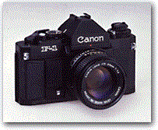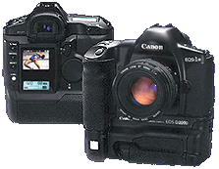
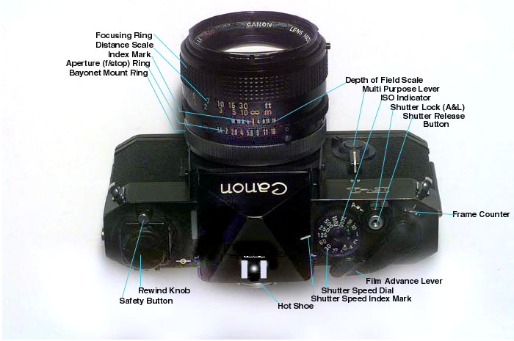
FIGURE 1-1 35mm SLR Camera

Familiarize Yourself with the Camera.

You should inspect the camera and familiarize yourself with its controls. Learn how they operate. Figure 1-1 shows the location of the Canon F-1 35mm SLR camera controls and indicators. If possible, obtain a camera, similar to the F-1 for examination and familiarization during this subcourse.

NOTE: The generalized instruction and information concerning digital camera systems and systems operation provided in this subcourse is not a substitute for a manufacturer’s system-specific procedures and guidance. After completing this subcourse, familiarize yourself with the digital camera, related peripheral equipment and documentation (owner’s manual/user’s guide) you expect to use.

o Film advance lever. Advances film one frame at a time, cocks the shutter, prepares aperture and mirror for exposure and advances the frame counter one number. A digital camera won’t have a film advance lever. The shutter will be cocked automatically and the number of images recorded will be electronically displayed.

o Shutter release button. Releases the shutter, initiating the exposure.

o Shutter speed dial. Indicates optional shutter speeds and sets the length of time the shutter remains open during an exposure. Shutter speeds are indicated in fractions of a second (60 = 1/60th of a second). The higher the number on the dial, the faster the shutter speed (and the shorter the exposure).
o ASA/ISO setting. Some films are more light-sensitive than others. This dial adjusts the light meter accordingly. A digital camera uses ISO settings to adjust the sensitivity of a CCD (charged-coupled device), a computer chip which electronically converts light into digital data.

o Aperture ring. A ring around the lens with a scale listing aperture numbers (i.e. 2.8, 3.5, 4, 5.6 etc.). These numbers are also known as "f/stops." The ring sets the f/stop on the lens to control the amount of light entering the lens.

o Rewind knob. Used to rewind film into the cassette (film canister), to tighten slack in loaded film, and to open the camera back.

Lenses and Apertures

Most professional SLR and digital camera systems have interchangeable lenses. The "focal length" of a lens is the distance from the optical center of the lens to the focal plane (film/CCD plane), when the camera is focused upon an object at infinity. Focal length determines the size of the film/CCD image. A 50mm focal length lens is considered the "normal" lens because when you look through the viewfinder objects appear at their approximate normal size. A smaller than normal focal length (like 28-35mm) provides a wider angle of view. However, objects will appear smaller than normal. A telephoto lens has a longer than normal focal length (135mm) which, like binoculars, makes objects appear larger than normal. Zoom lenses (35-105mm or 80-200mm) are designed with adjustable focal lengths.

The lens has "f/stops" or diaphragm aperture settings (see figure 1-1) which includes the numbers 3.5, 4, 5.6, etc. These control the amount of light passing through the lens and striking the film or CCD. The higher the f/stop number, the smaller the amount of light allowed to enter the camera lens. Aperture f/5.6 lets twice the amount of light strike the film as aperture f/8. Another way of saying it is that f/5.6 is "one stop larger" than f/8. Click stops between the apertures are "half stops." F/stops can range from f/1.4 to f/22; the larger the number, the smaller the aperture. The f/stop is always read as a whole number, not as a fraction or ratio. The meaning of "f/8" is that the diameter of the opening in the diaphragm is one-eighth of the lens' focal length (Figure 1-2).

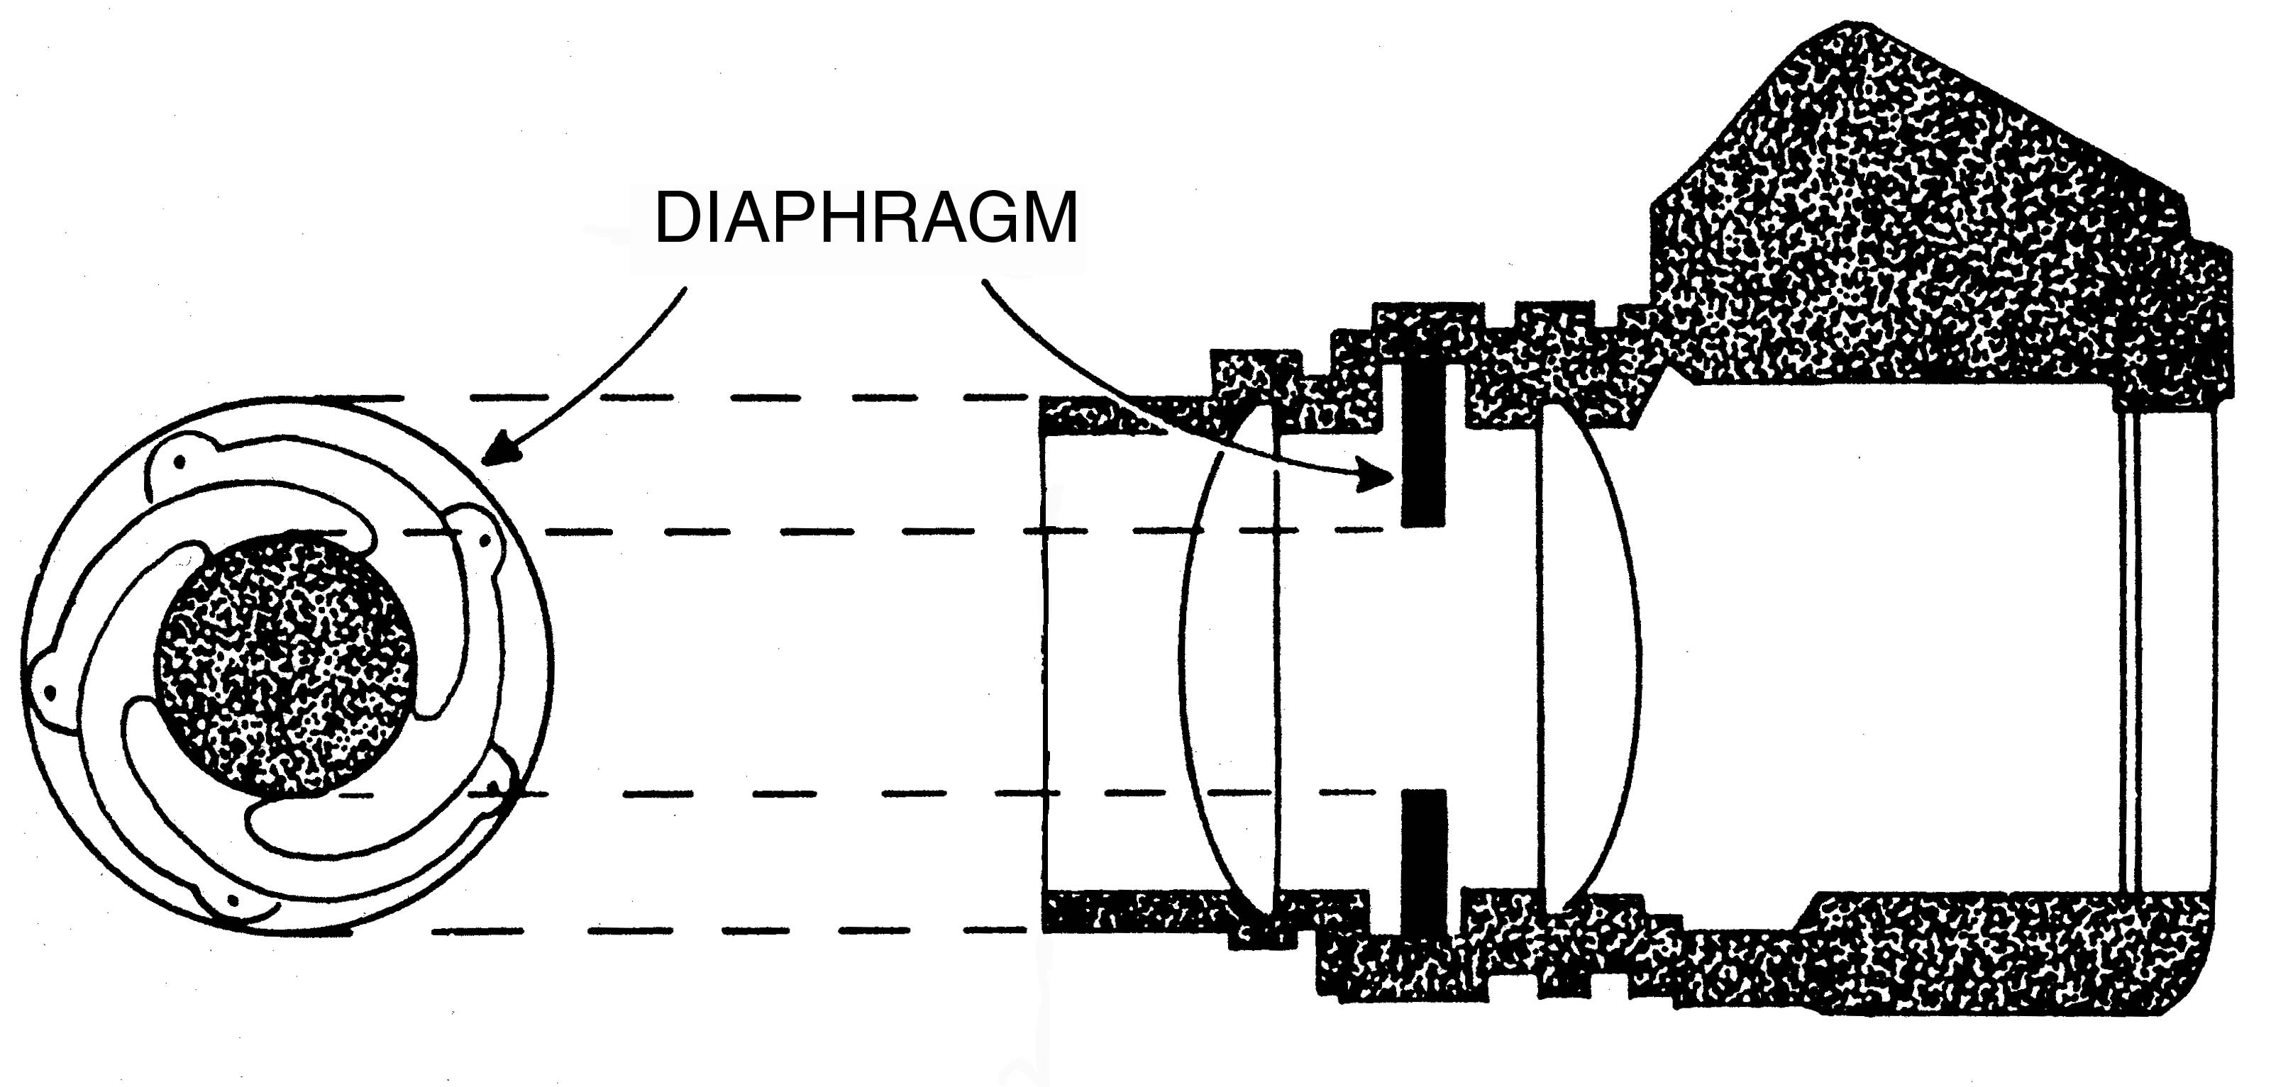
FIGURE 1-2. DIAPHRAGM

Shutter Speed

o General. The camera shutter is an adjustable mechanism that can be opened and closed for predetermined lengths of time to regulate the amount of light permitted to pass through the lens. The shutter speed control on the 35mm camera (see Figure 1-1) is usually a dial with a scale that includes the numbers 500, 250, 125, 60 etc. Shutter speeds control the duration of time (usually, fractions of a second) that light is allowed to pass through the lens aperture to reach the film. The shutter speeds usually range from 1/1000 of a second to one second or more. Unlike aperture settings that can be set between the marked f/stops, there are no intermediate shutter speed settings on a manual camera.

Each marked shutter speed admits one-half or two times the light of the adjacent speed. 1/125 second lets in half the light that 1/60th second lets in. 1/125 second lets in twice the light that 1/250 second lets in. A lot of light will get to the film when the shutter speed is slow. Shooting without a flash, hand-held photography of stationary objects requires a minimum shutter speed in order to prevent "camera shake." "Camera shake" is especially noticeable in photographs taken with telephoto lenses (ever try to look through a powerful telescope without a tripod?). To prevent it you should choose a shutter speed close to the focal length of your lens. Example: a 50mm lens could be hand-held at 1/60 second...a 135mm lens could be hand-held at 1/125 second. If the camera is mounted on a tripod or a steady support, speeds of less than the recommended speed can be used.

o Digital Camera Systems. Professional DCS (and many advanced 35mm cameras) have design features (programs) that electronically control and coordinate shutter speed and aperture value (f-stop). This permits the photographer to select a shooting mode appropriate to the particular assignment or shooting conditions. For example, the Kodak 520 DCS provides the following six modes.

Program AE Mode. In Program AE mode the camera automatically sets the Shutter speed and aperture value according to the subject brightness. This mode allows anyone to start capturing images quickly without worrying about exposure settings. Five focusing points provide a wide focusing area, making it easy to try out various picture compositions.

Shutter-priority AE. In this mode, you set the shutter speed and the camera automatically sets the aperture according to the lighting conditions.

Aperture-priority AE. In this mode, you set the aperture and the camera automatically sets the shutter speed according to the lighting conditions.

Depth-of-Field AE. This mode places everything between two points, one in the foreground and one in the background within the zone of focus, effective for making sure everyone in a large group picture or everything in a landscape photo is rendered sharp. After you designate the near and far points in the scene, the camera automatically sets the optimum focus position and the aperture necessary to achieve the required depth of field, then sets the shutter speed to achieve the correct exposure. The near and far points can be designated using the selected focusing point in Manual Focusing Point Selection mode, or using the center point in Automatic Focusing Point Selection mode.

Manual Exposure. This program mode lets you set both the shutter speed and aperture. Use this mode when you need complete control of exposure for creative effects or when using a hand-held exposure meter. The Main dial sets the shutter speed and the Quick Control dial sets the aperture.

Bulb Exposure. The shutter stays open for as long as you press the Shutter button. Use this mode when long exposures are required, such as for pictures of night scenes and fireworks displays.

Film Speed, ASA and ISO Settings

The ASA rating and its modern equivalent, the International Standards Organization’s ISO number, began as rating of film speed. Film speed/ISO is the relative sensitivity of film to light. “Faster” films, those with higher ASA/ISO ratings, have greater light sensitivity than “slower” films. While ISO 400 film is a reliable, general-purpose choice, films with an ISO rating of 3200 or 1600 are a better choice for shooting under subdued light; ISO 60 or 100 films would be appropriate for outdoors use on bright, sunny days. Higher speeds/ISOs may result in lower-quality images than lower speeds. (You may notice grain or snow in the image.) Therefore, you may want to use a flash and a lower ISO setting. In digital photography, ISO numbers are used to adjust the light-sensitivity of the camera’s charge-coupled device (CDD), a computer chip that electronically converts light into a digital image.

The 35mm SLR camera has an ASA/ISO setting control (usually a small ring located around the shutter speed dial as in Figure 1-1). Normally, you should adjust the setting to match the ASA/ISO of the film you will use. For a digital camera, set the ISO in accordance with the manufacturer’s recommendations for the lighting conditions. Generally, when selecting an exposure setting, begin with lower exposure index settings; reserve the use of higher speeds for situations requiring their use.

Digital camera users will also select the file format (TIFFs or JPEGs) in which the image will be recorded. (JPEG is the most common format for still images.)

Exposure

The term "exposure" is used with a variety of meanings at different times. Photographers often use the term "exposure" to indicate combinations of shutter speed and lens aperture (f/stops). This is properly called "camera exposure."

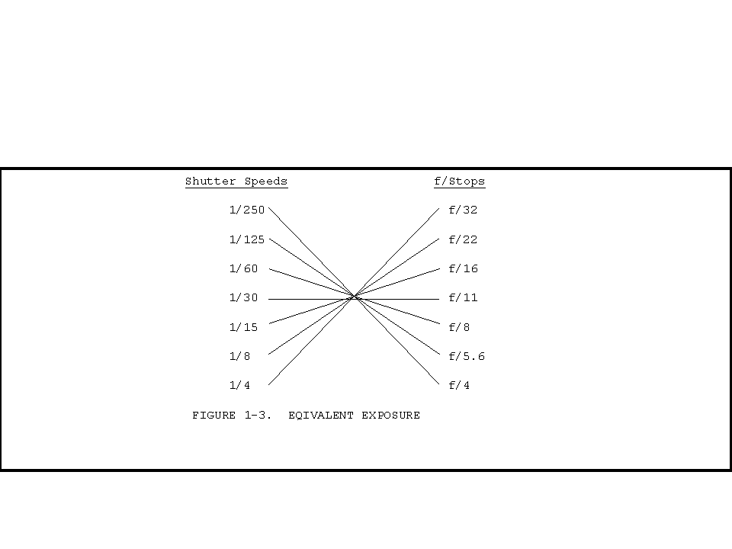
Various combinations of f/stops and shutter speeds can give the same camera exposure. This is called "equivalent exposure." Example: A starting exposure combination of 1/250 second at f/4 can be changed to an equivalent exposure of 1/30 at f/11 (see Figure 1-3). This can then be changed to an equivalent exposure of 1/125 at f/5.6. Each time you increase the shutter speed by one setting (allowing less light in) you must open up the aperture by one stop.
FIGURE 1-3

EQUIVALENT EXPOSURE

Again, various combinations of lens aperture and shutter speed can give the same camera exposure. The key is that these combinations allow the same total amount
of light to pass through the lens, and onto the film. Any given subject will reflect a variety of light. By this we mean various object brightness will reflect varying amounts of light. Without these various reflectances, we would not have an image on the film. All we would have is an even tone or shade of gray. Thus, the camera settings must be adjusted so as to produce the correct range of camera exposure on the film for your particular subject (Figure 1-4).

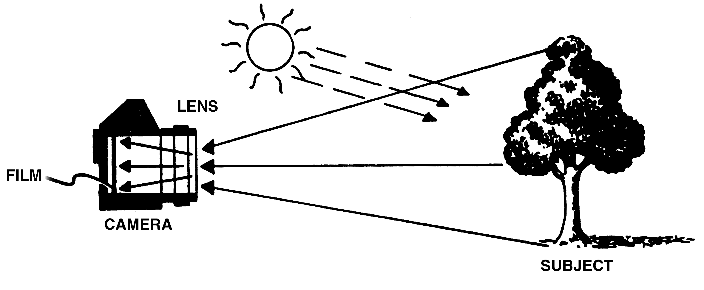
FIGURE 1-4. EXPOSURE

Another meaning of "exposure" is "film exposure." This refers to how the film has been exposed. Did it come out too light or too dark? There are four variable, and interrelating, factors in getting the correct film exposure:

o The speed of the film or CDD sensitivity (ASA/ISO).

o The intensity and nature of the light.

o The lens aperture setting.

o The shutter speed setting.

Modern 35mm single-lens reflex and digital cameras have built-in exposure meters. Before the exposure meter can give out accurate information, it must be programmed by "dialing in" the ASA/ISO of the specific film being used. This is usually done with a small ring (the ASA/ISO setting) located around the shutter speed dial or by adjusting a knob or switch. You are not "changing" the ASA/ISO of the film. You are telling the exposure meter what the ASA/ISO of the film is or in the case of a digital camera, adjusting the sensitivity of the CCD.

The objective of photography is to capture not only form but the true colors, shades and hues of that form. Because the camera’s ability to capture these are influenced by extremes of lighting conditions (indoor fluorescent or tungsten lighting, versus outdoor sunlight, etc.), appropriate camera settings and film or combinations of film and flash must be used. In digital photography, “white balance” adjustment compensates for these lighting extremes. The digital photographer focuses on a nearby white object to calibrate the camera.

OPERATING THE CAMERA

Loading the Digital Camera With Recording Media
A digital camera will use one of several systems to store both the recorded digital images and their associated sound files. These include --

Internal “hard drive” or solid-state storage medium, which are not removable.

Removable media. After the camera is powered down, an access door or panel is opened to install or remove the recording media. Consult the instructions in your owner’s manual since procedures vary by make and model of camera.

PCMCIA Type III or “PC” card (FIGURE 1-5). This is a standard, .41 inches thick, credit card-sized card that meets the Personal Computer Memory Card International Association’s standards for image storage, the PCMCIA-ATA interface standard. Army PA organizations are authorized a DCS that can use PMCIA cards. This is a type of “removable hard drive.” PMCIA Types I and II cards are slightly thinner and have less capacity. Recording capacity is stated in megabytes or gigabytes.
Many DCS use “compact/flash cards” (FIGURE 1-6). Although DCS which use these media exclusively are found within some DoD organizations, their relatively low storage capacity can limit their usefulness as working tools for Army PA professionals. Adapters which permit the use of “flash cards in PMCIA card slots are available for the DCS meeting Army PA-use specifications. Flashcard solid-state technology offers ruggedness unmatched by PCMCIA cards with their mini-hard drive component. Flashcards will normally retain their digital images for many months but data can be lost if they are subjected to strong magnetic fields or electronic signals. The firmware program formats PC cards for data storage.

The image capacity (the number of images than can be recorded until the drive is “full”) of the storage media depends on more than just the megabyte capacity of the PCMCIA card itself. For example: a 520 MB PCMCIA card can normally record 150 to 200 images but this number is greatly reduced when sound files are added. (Many DCS have sound-file recording capability, feature that allows the journalist to record information (a “tag”) pertaining to a particular image.)

To keep your camera serviceable you must ensure that it retains sufficient recording capacity. When you return from an assignment, you will normally upload the data files from your PC card into a computer for processing and delete the files from the card thus restoring its original recording capacity. If this cannot be accomplished, you may need to use the camera’s image delete feature to make room for new images or replace the used card with a fresh one.

PC CARD TYPE III COMPACT/FLASH CARD
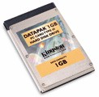
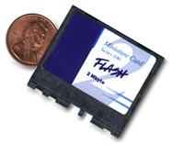

FIGURE 1-5 FIGURE 1-6
Powering Your Camera

Electronic Flash. – Electronic flash operation requires a power source. Power is usually supplied by replaceable (usually, AA or AAA alkaline) or rechargeable batteries of appropriate type and quantity placed in the battery compartment of the flash unit. An external battery pack connected to the camera/flash unit by a flexible power cord may also be used. Consult the owner’s manual for specific requirements and instructions. It is a good practice to begin an assignment with fresh batteries and to carry spares.

35MM SLR Cameras – Some older cameras are manually operated and do not require an electrical/battery power source. However, many modern 35MM models have battery-operated components. Consult your OM for specific details.

Digital Camera Systems – DCS operation requires a reliable source of power. Automation of camera setting adjustments, recording and downloading digital images and audio tags all require power. All professional DCS have a visual display that let you monitor the condition of its power supply. Power sources and configurations for most professional DCS include –

Integral battery. Usually considered non-removable in normal service, these are recharged between assignments with an AC battery charger/adapter connected to a commercial power source or generator. Given an electrical source/outlet at the shooting location, the battery may be conserved and the AC adapter feature used to power the camera. Note: DCS currently approved for Army PA units do not use an integral battery.

Replaceable battery (FIGURE 1-7). The primary source of power for DCS approved for use by Army PA units is the replaceable and rechargeable NiCAD, NiMH or LiO battery pack. While fully charged battery can power approximately 300 images, use of the liquid crystal display (LCD) to preview stored images reduces this number appreciably. Approved DCS have a design feature (access door) which permits easy replacement in the field (FIGURE 1-8). Check the OM to ensure that the battery pack is appropriate for your DCS.

Battery charger (FIGURE 1-7). The battery charger consists of a battery receptacle and an electrical transformer which reduces the voltage from a commercial source, automotive power outlet or generator to the voltage required by the charger. Ensure the battery charger Check your equipment documentation for user instructions and equipment limitations.

AC Adapter (FIGURE 1-9). AC voltage adapters convert electrical power from an available external source (input) to a voltage that can be used (output) by your camera. You may want to use it to conserve the battery when shooting indoors. It also ensures a reliable source of power when downloading images from the camera into the computer. In North America, 110 volts AC is the commonly supplied house current, drawn from the two- or three-hole wall sockets common in our homes and offices. However, there is no international standard. Many other voltage and plug configurations exist. (Great Britain uses a 210-volt system and four different types of plugs!) Your kit (FIGURE 1-10) must contain plugs or cables configured for your area of operation. Some general rules-- Use only the AC adapter designed for your camera. Use only the type(s) of power source indicated on the adapter; a line voltage outside this range can destroy the AC adapter and the camera. Never plug other adapters into the camera or use the AC adapter supplied with your camera for any other purpose. Consult your operator’s manual (OM) for specific instructions concerning use of the AC Adapter.
Transformer and Charger with Battery Battery Insertion/Removal

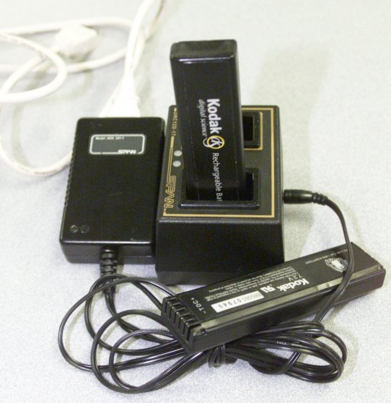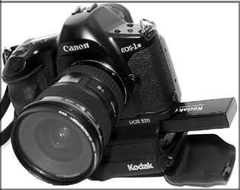

FIGURE 1-7 FIGURE 1-8

AC Adapter
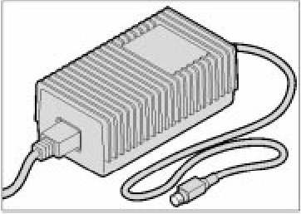
FIGURE 1-9

Universal Cable and Plug Assortment

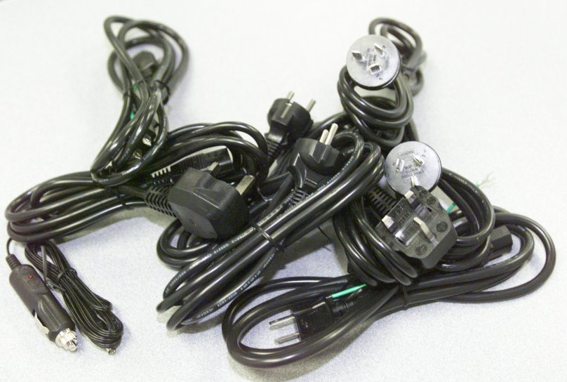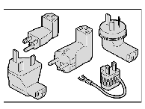

FIGURE 1-10

Freezing the Action

Why would you want to increase the shutter speed? One reason would be that you have too much light -- even though your aperture is on the smallest setting. Shooting photos at a beach or on a snow-covered mountain would call for a high shutter speed.

Another advantage of high shutter speeds is that they tend to freeze the subject. Your pictures can suffer from "camera shake" if you are not using a tripod to hold the camera still. One way to get around this problem is with a high shutter speed. Besides camera movement, you may have the problem of subject movement. Sports pictures often call for a higher shutter speed to freeze the subject in mid-action. To photograph moving objects, a shutter speed in excess of 1/125 second is ordinarily required. Direction, distance from the subject and speed of movement are factors in determining correct shutter speeds. A distant object moving toward you would not be blurred as easily as a nearby object moving from left to right at a high rate of speed -- more factors equal higher shutter speed.

Another reason for using a high shutter speed might be to allow for a large aperture (f/1.8, f/2 or f/2.8). Large apertures lessen the "depth of field," causing the background to soften or blur. This is called "selective focus" and is useful in eliminating background distractions.

Getting it in Focus

A camera is focused by moving the lens closer or farther from the film (or focal) plane. On professional 35mm cameras, the lenses are mounted on a threaded mount that permits precision movement of the lens by rotating a ring or some similar device. On many DCS, this is done electromechanically.

Modern 35mm and digital cameras

Many modern 35mm cameras and all professional digital cameras have design features, which permit a choice of several automatic and manual focus control options. Automated shooting modes offer convenience and allow the photographer to provide a useable product that captures candid, unposed action. However, expert manual adjustment and control of each focus element yields consistently better products. Therefore, use manual options when the nature of the shooting assignment permits planned shots or careful measurements.

Focusing Aids

There are aids that are used to help obtain correct focusing:

o Viewing Screen. One method is to simply turn the focus ring (located on the front of the lens barrel) until you see a sharp image on the viewing screen.

o Viewfinder Focusing Aid. Most modern DCS have "micro prisms," "split image" aids (see Figure 1-14), or some combination of both. These can be useful under most conditions. But they have limitations when used with wide-angle lenses and telephoto lenses.

o Distance Scales. The distance scale, located on the cameras lens barrel, is often ignored. However, it is the most accurate method of focusing.

Study the OM description of the focusing aids for the camera you will use.

Depth of field

Because of the laws of optics, a smaller aperture means that more things will be in focus in a photograph. In the example of f/16 at the beach, not only would the horizon of the ocean be in focus, but so would the sand bucket sitting three feet in front of the camera. The distance between the closest object in focus and the farthest object in focus for a given lens focal length and f/stop is called the "depth of field" (see Figure 1-11). Most 35mm SLRs and DCS have a depth-of-field scale incorporated in the distance scale. By using it properly you can set the camera to best advantage. (Example -- You are shooting at f/22 with a 55mm lens. The depth-of-field scale shows you that you can get everything in focus from five feet to infinity.)

Because of the laws of optics, shorter focal length lenses (wide angle - i.e. 28mm) have greater depth of field than long focal length (telephoto - i.e. 135mm) lenses. A short focal length lens with a small aperture gives maximum depth of field.

When you don't have as much light to work with you may have to open your aperture (use a larger f/stop - i.e. f/2.8). On a dark, stormy day at the beach you would be lucky to get the shore and the horizon both in focus, because instead of f/16 you might be using f/3.5.
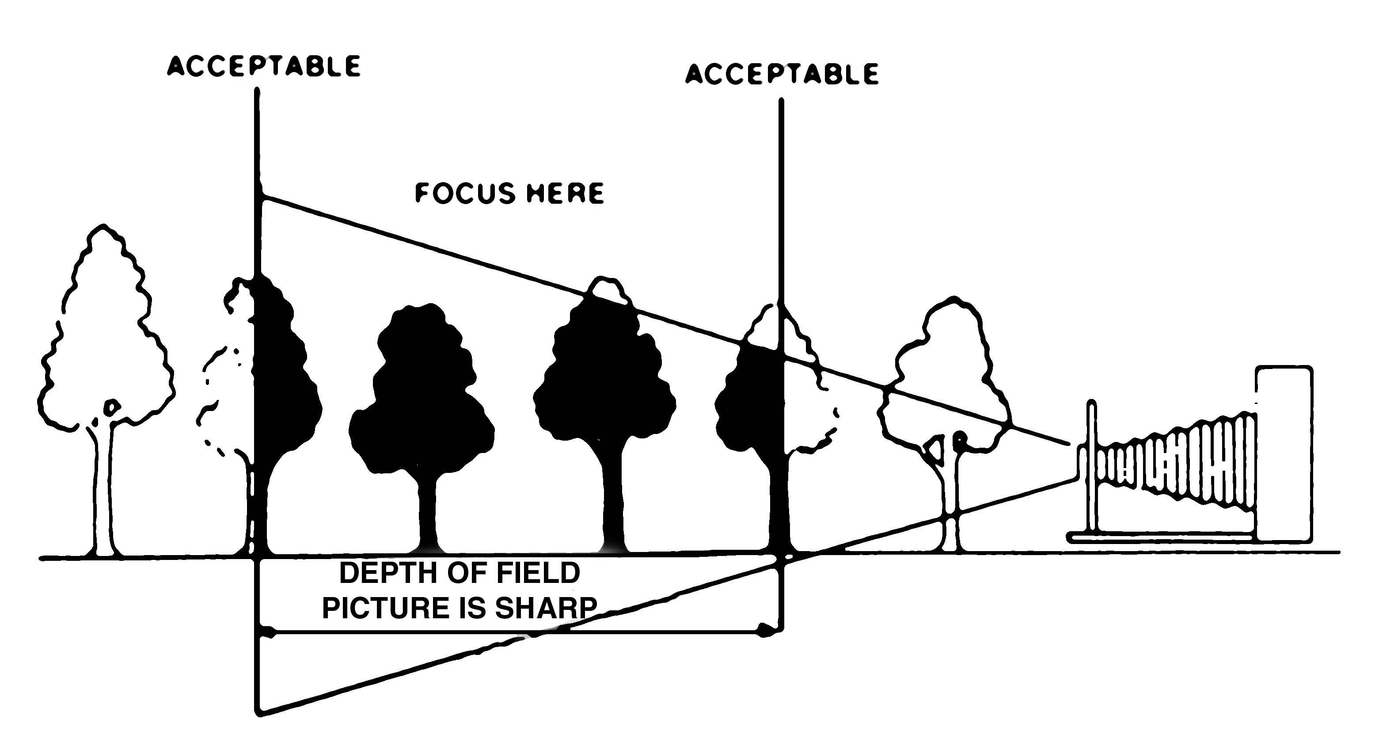
FIGURE 1-11. DEPTH OF FIELD

Trade offs
In photography there are trade-offs. As the aperture size is decreased to increase the depth of field then the shutter speed must be decreased (see Figure 1-12).

Note: It may be helpful to think of f/stop numbers as fractions. For example: 1/32 (f/32) is less than 1/22 (f/22); f/22 is “a step down” from f/16.

Increase Action Increase Depth-
Stopping Capabilities of-Field





Decrease Action Decrease Depth-
Stopping Capabilities of-Field

FIGURE 1-12. DEPTH OF FIELD vs ACTION STOPPING CAPABILITY

On a stormy day at the beach you could still have a large depth-of-field if you used a slow shutter speed like one second. But a moving boat would be nothing but a blur because of the slow shutter speed. One way to solve this problem would be to use a film that is more sensitive to light or a higher ISO if you are using a digital camera. High-speed films (usually classified as ASA/ISO 400 and up) can be used to solve the problem of low light levels. A high-speed film doesn't need as much light for a proper exposure. Here, too, there is a trade-off. Higher-speed films are "grainier" than lower-speed films. Through a magnifying glass every photograph can be seen to have a granular pattern. In high-speed films this grain pattern is more pronounced. Using higher ASA/ISOs with a digital camera can result in some shift or loss of color values. Another quality of film called "sharpness" (not to be confused with focus) can also be related to film speed. Generally speaking, the slower films and lower ASA/ISOs will give more accurate reproduction of a subject.

PICTURE TAKING

While some of the procedures described below are only appropriate for the operation manually operated 35mm SLR cameras, most of the procedures and all the photographic principles apply to both advanced 35mm cameras and digital cameras.

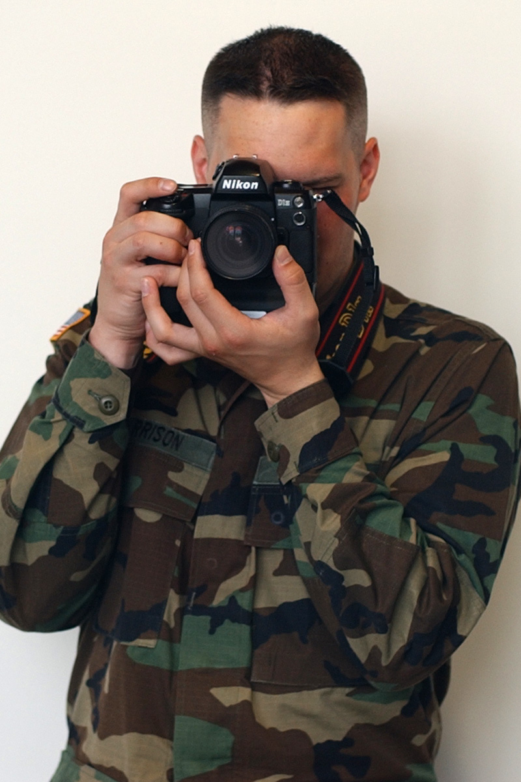
When you can’t use a tripod, hold the camera in such a way as to provide support to the base. It allows the manipulation of controls and provides a reasonably steady platform for the camera, thereby reducing camera movement. It also ensures that your fingers won’t inadvertently cover a portion of the lens! The method can be used for both horizontal and vertical format photography and is the same for right- or left-handed people.

Grasp the camera, lens facing forward, by the right side of the camera with the right hand. The index finger and thumb of the right hand controls the shutter-release, shutter speed controls, or camera specific controls located nearest the shutter release. The left hand cradles the camera for support leaving the thumb and index finger free to control focus and other controls located on the lens. The elbows should be held against the body to provide support.
(Figure 1-13-A)
Figure 1-13-a Correct
horizontal method

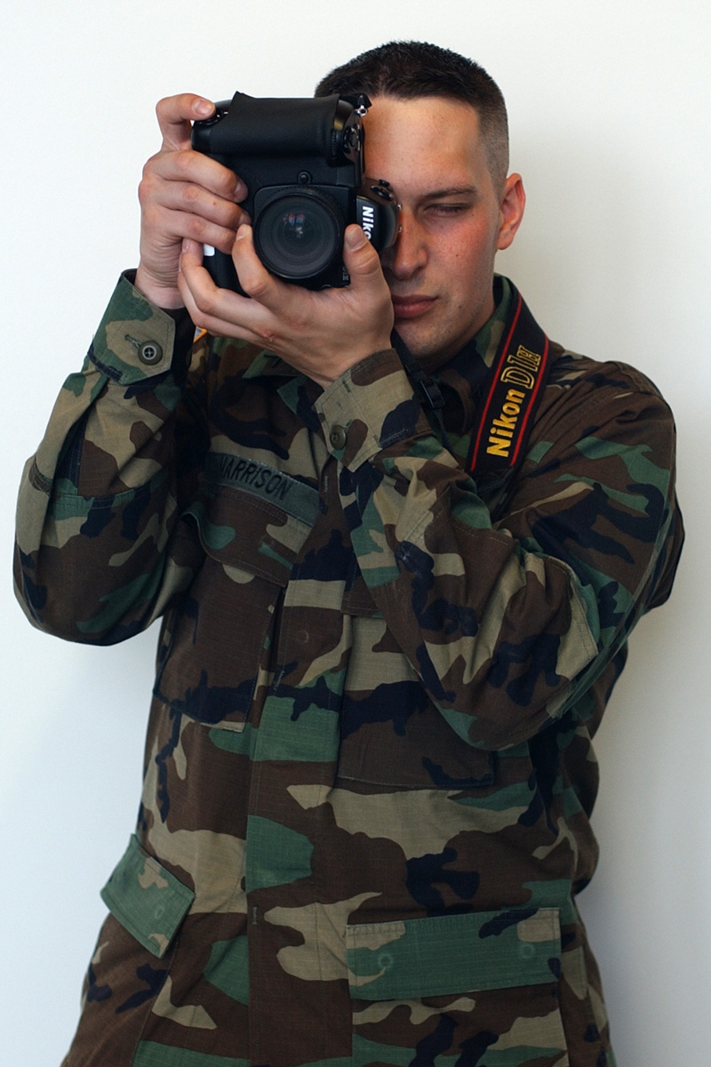
On vertical shots the left elbow should be placed against the body for support. (Figure 1-13-B) For very long (telephoto) lenses cradle the lens in the left hand or use a tripod for support.

Many digital cameras have extended bodies that do not lend themselves to cradling the lens in the left hand. By supporting the base of the camera with your left hand, you can provide a steady platform while keeping your fingers away from the lens.

An example of improper camera handling can be seen on the next page.
(Figure 1-13-C)
Figure 1-13-b Correct
vertical method

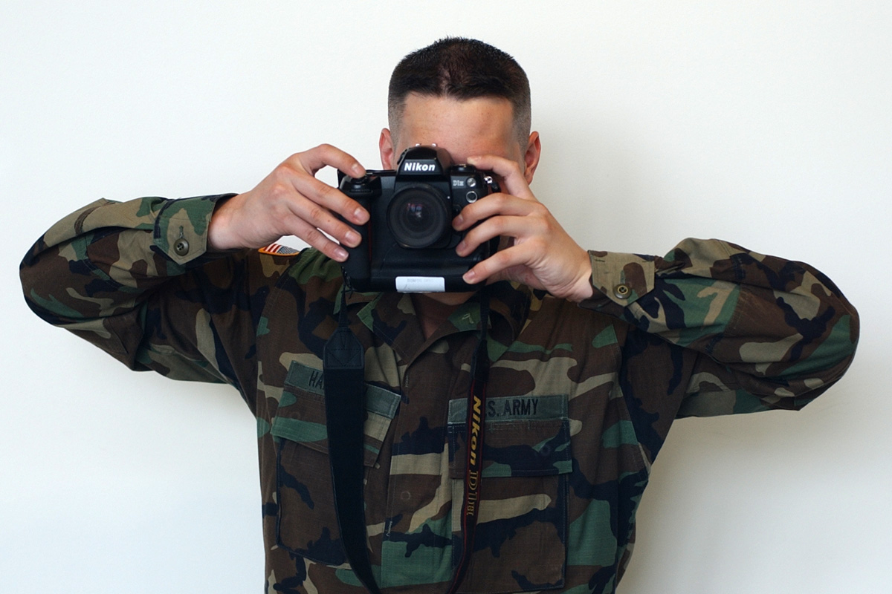
Cameras and lenses will vary depending on inventory. However, practicing these methods and applying them to the equipment on hand will result in fewer instances of blurred or unusable imagery.
Figure 1-13-c Improper handling of camera

Focus

Focus the camera on your subject. Look through the viewfinder. With the thumb and index finger of your left hand, rotate the focus ring until you obtain a sharp focus on your subject (see Figure 1-14). Many modern cameras have “pushbutton,” electromechanical focus controls and several automated, semi-automated or manual focus modes. See your OM for specific information.
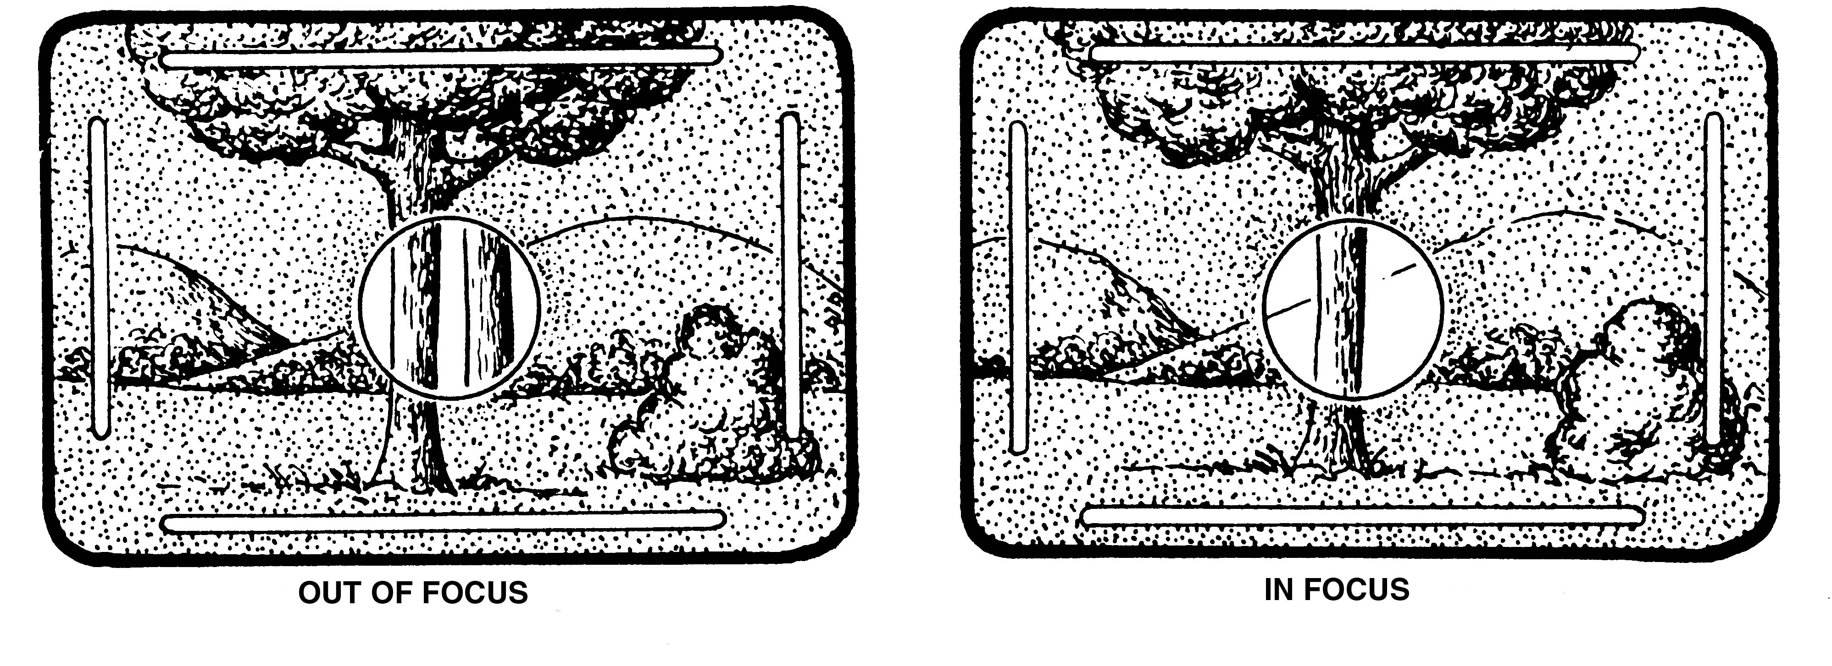

FIGURE 1-14. FOCUSING AID

Set the Film Speed/ISO Control

No matter how experienced you are, you should continue to make this vital check. The film speed dial is incorporated into the shutter speed dial of most 35mm SLRs (like the Canon F-1). Set the ASA/ISO dial to match the film's rating; e.g., for Kodak Tri-X you would set it at 400. For a DCS, set the ISO in accordance with the manufacturer’s recommendation for the lighting conditions under which you will be shooting.

Activate the Light Meter

The meter on-off switch is located on the back of the Canon F-1. The light meter can be left on throughout the shooting assignment. A light-sensitive photocell moves a meter needle inside the Canon F-1’s viewfinder. When it is in line with the aperture needle, the F-1 is set for a proper exposure (see Figure 1-15). Many advanced cameras have shooting modes that integrate the light meter with aperture and shutter controls. In battery check mode, a meter needle position below the fixed index denotes a low battery. Refer to the owner's manual for other cameras.

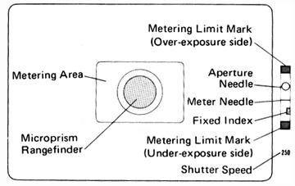

FIGURE 1-15. LIGHT METER
Set the Shutter Speed

The film manufacturer's instructions provide time-tested shutter speeds for varying light conditions, e.g., sunny, overcast and cloudy. However, photographers often prefer to freeze action or blur motion, and in doing so must manipulate the shutter speed in concert with the aperture control ring. To capture a runner, the photographer may set his camera at 1/60th of a second to illustrate the speed; the runner's legs and arms are a blur of motion on the finished photograph. If the photographer wants to freeze the action, he sets his camera at 1/250th or higher; the legs, arms and victory expression are "frozen." For hand-held shots, choose a shutter speed no slower than the speed closest to the focal length of the lens. Examples: 50mm lens -- 1/60th of a second; 200mm lens -- 1/250th of a second. Many professional DCS coordinate shutter speed and aperture control as a design feature. Consult the owner’s manual for the control/setting options available for your camera.

Set the Aperture Control

Adjust the f/stop on the aperture control ring to match the light meter requirement.

The aperture control can be used to increase or decrease the depth of field. Increased depth of field is achieved with higher f/stop settings (smaller aperture openings)(f/11, f/16, f/22). A narrow depth of field is achieved with lower f/stop settings (f/4, f/2.8, f/1.4).

In a situation where you are assigned to shoot a photograph with two subjects in the field of view, one in the foreground, the other to the rear, the following would apply:

o At an aperture setting of f/4 and a shutter speed of
1/250th, only the subject in the foreground is in
focus. You adjust the aperture to f/8, and
now both subjects are in focus. The depth of field
was increased by "stopping down" two f/stops.

o The shutter speed was changed to 1/60th in order to
get an equivalent exposure.

Shutter speed and aperture control are correlated. Whenever you manipulate the aperture control to alter depth of field, you must make an appropriate change in the shutter speed. To maintain a correct exposure, increasing the shutter speed by one setting must be answered by lowering (or opening up) the f/stop one setting. Likewise, decreasing the shutter speed by one setting must be answered by closing (or stopping down) the f/stop one setting. Example: A correct exposure of 1/250th at f/8 is obtained by an initial light meter reading. The following adjustments can be made in shutter speed and aperture settings without affecting the exposure:

SHUTTER SPEED APERTURE
1/30 f/22
1/60 f/16
1/125 f/11
1/250 f/8
1/500 f/5.6
1/1000 f/4
1/2000 f/2.8
Steady the Camera

Avoid camera movement unless you are intentionally using a creative technique, such as panning (following a moving subject). The best way to steady the camera is with a tripod, but they are not usually used by reporters in a hurry to meet deadlines. Wrapping the neck strap tightly around your right wrist and tucking your elbows into your waist will help to steady the camera. Pressing your shoulder or back against a wall, a tree or some other stationary object will also help steady you. Using the camera's self-timer to release the shutter instead of depressing the shutter-release button with your finger is also helpful in some situations.

Composition

Your job as a photographer is to take pictures that best serve the purpose of your assignment. How well you do depends on how you use the necessary technical controls.

The most basic control is composition. Crop (cut out unwanted parts of the picture) within the camera's viewfinder while taking each frame.

Employ the elements of photographic composition, including the "rule of thirds."

The rule of thirds uses two vertical and two horizontal lines to divide the viewfinder into nine equal parts (see Figure 1-16). The subject (center of interest) should be positioned at or near one of the four focal points (intersections), depending on the direction the subject is moving or looking. Subjects centered in the viewfinder create a dull, static photo.

FIGURE 1-16. RULE OF THIRDS

When photographing a runner or other moving subject, allow him space to run into. Examples of this can be seen in most any newspaper or magazine photograph.

The same is true of a simple portrait; allow space for an individual facing left or right to look into. Crop as much as possible within the camera, eliminating any distractions. Obtain a variety of horizontal and vertical shots from a variety of angles to give the editor more flexibility when laying out the story and photograph(s).

Shoot the Picture

First, adjust the focus so that the image in the viewfinder becomes sharp and clear. Now, lightly depress the shutter-release button until the camera clicks. Advance the film to the next frame, and you are set for the next exposure.

Record the “cutline” data for each frame or series of frames. A notepad, tape recorder or audio “tag” may be used if your camera has this feature. Note each frame and the names of individuals, the action taking place (the five W's and H) and the nomenclature of any unusual equipment. If possible, record each frame as you shoot it.

INSPECTING THE CAMERA

Besides knowing how to operate the camera, it is important that you know how to take care of the camera. Before going on an assignment you should thoroughly check your camera.

The Lens

Remove the lens from the camera in accordance with the manufacturer's instructions and inspect it. Check the glass for dirt, smudges, fingerprints and scratches. Dirt can be removed from the lens by carefully using a blower brush. Dirt, smudges and fingerprints can and should be removed from the glass as soon as noticed by gently wiping the glass with lens-cleaning tissue moistened with a couple of drops of lens-cleaning fluid (don't use more than that). Minor scratches may not alter lens performance so as to deem it unusable, still, scratches should be duly noted and brought to the attention of your supervisor. Deep scratches probably will affect lens performance. In this case, notify your supervisor and seek a replacement lens. If in doubt, attach the lens to the camera body, look through the viewfinder and focus on a subject. If any part of the field of view appears blurred or obscured, the lens should be replaced. Check the lens exterior for dents and other damage. Lastly, make sure the lens is mounted with either a UV (ultraviolet), haze or skylight filter to protect the front glass surface and its delicate coating (this ultra-thin coating on each glass surface reduces reflections). Perform similar checks on other lenses in your kit.

Check the lens aperture control ring, or the f/stop ring. The f/stop ring should firmly click into each position. Check the focus ring. It should move smoothly, without interruption.

The Camera Body

Inspect the camera body for dirt and defects. Dirt should be removed from the camera body with a blower brush. Hard to remove dirt can be removed with a silicon cloth or a soft chamois. Do not use liquids to clean the camera body. Liquid cleaners, including water, can damage the camera. Camera body damage should be reported to your supervisor.
CAUTION: Because digital camera systems include electronic components which can be damaged by static electricity, special precautions may be necessary. Inspect and clean digital cameras and their associated peripherals in accordance with the instructions provided in the owner’s manual.

Inspect the Camera Optics

Look through the camera's viewfinder. Focus on an object. If the field of view is blurred or obscured, you may have a damaged lens, or perhaps the viewfinder is dirty.

If the mirror is dirty, very carefully clean it using the blower brush. Do not use lens-cleaning tissue or fluid on the mirror. If smudges remain on the mirror, consult with your supervisor prior to taking the camera body to an authorized dealer or repairman for professional cleaning.
Inspect the Light Meter

Check the camera battery/internal light meter. Consult your manufacturer's instructions for the proper method of conducting this very important systems check. A weak battery can affect your light meter readings and, ultimately, your exposures.

Inspect Straps

Inspect the neckstrap for cracks and wear, especially at the pressure points -- the clips which attach it to the camera. In wet and humid climates, leather neckstraps have a tendency to rot and should be checked daily. Adjust the neckstrap to your needs. Always use the neckstrap as a safeguard against dropping the camera. (Caution: You can be held liable for any damage to the camera.)

You should clean the camera equipment as required. Always store the camera in its case with the lens cap over the protective filter.
PRACTICE EXERCISE

LESSON 1

SUBCOURSE NO. PA0250

OPERATE A CAMERA

INSTRUCTIONS:

Review the material in this lesson. Use your mouse cursor to select the correct answer ("T" or "F") to each question.

T F 1. The camera's aperture controls the amount of light passing
through the lens and striking the film or charge-coupled device.

T F 2. The "focal length" of a lens is the distance from the optical
center of the lens to the focal plane.

T F 3. The use of automated rather than manual focus and exposure adjustments
by a skilled photographer usually results in better products.

T F 4. Shutter speed controls the duration of time that light is allowed
to pass through the lens aperture to reach the film or CCD.

T F 5. An advantage of high shutter speeds is that they tend to freeze
the subject.

T F 6. In aperture readings lower numbers means less light is admitted
through the lens.

T F 7. A well-written book on digital photography is a good source
of information on the operational characteristics of digital
cameras and an adequate substitute for an owner’s manual.

T F 8. You want to emphasize a soldier in the foreground of a battle scene.
scene. You obtained a correct initial light meter reading of 1/250th
at f/8. Based on the chart below, you could do this by “stopping
down” the aperture to f/4 and setting the shutter speed at 1/1000th.

SHUTTER SPEED APERTURE
1/30 f/22
1/60 f/16
1/125 f/11
1/250 f/8
1/500 f/5.6
1/1000 f/4
1/2000 f/2.8

T F 9. According to the Rule of Thirds, it would be appropriate to position
your subject, a soldier observing a burning tank to his left, in the
left-most portion of your viewfinder.

T F 10. A digital camera system incorporates electronic components and
circuitry that automate its operation, convert light into a digital
image and allow it to “talk” to a computer.
ANSWER KEY

LESSON 1

SUBCOURSE NO. PA0250

OPERATE A CAMERA

1. True (Page 5)

2. True (Page 5)

3. False (Page 12)

4. True (Page 6)

5. True (Page 17)

6. False (Page 5)

7. False (Page 3)

8. True (Page 17,18)

9. False (Page 19)

10. True (Page 3)

LESSON TWO

EXPOSURE

46Q Soldier's Manual Task: 214-176-1315

OVERVIEW

TASK DESCRIPTION:

In this lesson you will consider how the light exposure encountered during a shooting assignment impacts a photographer’s choice of recording media and/or
ISO setting.

LEARNING OBJECTIVE:

ACTIONS: Describe how the conditions of a shooting assignment
influence the choice of the recording media/ISO setting
you will use.

CONDITIONS: You are given the material presented in this
lesson.

STANDARDS: Describe how lighting, subject, exposure and climatic conditions
can influence your choice of film and/or ISO settings.

REFERENCES: The material contained in this lesson was
derived from the following publications:

Soldier's Manual and Trainer's Guide for
Journalists
DINFOS Electronic Imaging Handbook

EXPOSURE AND RECORDING MEDIA

An understanding of exposure in relation to wet photography and ISO setting will help you to understand the significance of ISO settings to digital photography.

Film Speed

The "speed" of a film is determined by how fast the film reacts to light. The more responsive an emulsion is to light, the faster it is said to be. This means that less exposure to light is required to produce an image.

The silver halide grains determine how fast the film reacts to light. Some of these grains are highly sensitive to light while others are less sensitive. Varying the proportion of highly sensitive grains will affect the speed of the film.

Several systems have been developed to accurately compare the light sensitivity of different films. One of the most commonly used systems was developed by the American National Standards Institute (ANSI), previously known as the American Standards Association (ASA). This same system is used by the International Standards Organization (ISO). This system uses a speed rating in which numbers are assigned to emulsions to indicate their relative speeds. Doubling of speed is denoted by doubling of the numbers. For example, a film with a speed of 250 is twice as fast as one with 125; therefore, it takes half the amount of exposure to produce an image. Digital cameras use electronic ISO calibration settings.

These rating numbers can be seen on boxes of film with the letters ASA/ISO beside them. T-Max film, for example, would have ASA/ISO 400 on the box and Plus X Pan has ASA/ISO 125. Relatively speaking, films are termed either slow, medium or fast. An ASA/ISO of 40 would be a slow film, and ASA/ISO 125 would be medium. An ASA/ISO of 400 would be fast. Some films are extremely fast -- with speeds of ASA/ISO 3,200. The speed of the film you select or ISO setting of a digital camera is determined by the photographic assignment.

Grain

During manufacturing, the halide grains clump together. This determines the size of the grain in any film, and is called "inherent grain size."
Films can be broadly classified into low, medium, and coarse-grained emulsions. High-speed emulsions generally have larger grains than slow-speed emulsions and in digital photography, higher ISOs produce grainier images. Large grain size is undesirable except to achieve a special effect. However, they usually will not become apparent until you begin to make enlargements from your negative. You should use the slowest film, or lowest ISO, possible under the exposure conditions for optimum results.

Contrast

Contrast is the term used to describe how film will record the difference in tones between the lightest and darkest areas in the negative. This capability, which is also determined by the size of the grain, is incorporated into the film at the time of manufacture and is described as low, normal and high contrast. Normal contrast materials have the ability to form a wide range of grays and are used for a majority of general-purpose photography.

The shades of gray as they are reproduced in the negative and its subsequent print can be changed by factors other than the inherent contrast of the film. Such things as lighting, exposure, development and the developer can produce a negative that may be flat (lacking contrast) or hard (too contrasty). You can see an example of hard and flat contrast by adjusting the contrast dial of a T.V.

CHOOSING AN APPROPRIATE ISO SETTING

You must first consider the mission requirements. For each mission there are one or more factors that must be considered. Sometimes one factor offsets the other, or one may have an opposite effect on the other.

You should choose an ISO setting that will take the desired picture. The slower-ISOs will give you comparatively better grain and resolving power. Range of f/stops and shutter speeds available under the lighting conditions also dictate your ISO choice. For example, a portrait is normally shot with a wide aperture to reduce depth of field. Choosing a high ISOs for an outdoor portrait on a sunny day would limit you to fast shutter speeds and small apertures. Conversely, in low-light situations where wide exposure latitude is needed or on an airborne mission where fast shutter speeds and small apertures are desired, a high ISO is ideal.

Let's take a look at some examples and discuss how one would consider ISOs for different situations. Remember that these are hypothetical situations and are not meant to be exact solutions for that example.

Example #1: If the subject being photographed is in the area of poor illumination, a high ISO is desirable. A high ISO, however, has low resolution.

Example #2: Assume your assignment calls for photographing a subject having little difference in the shades of gray. In this case you need an ISO that can produce fairly high contrast. Again, higher ISOs have lower resolution. Proper lighting also can increase contrast.

Example #3: Suppose you are asked to take a photograph of an object, and the negative will be enlarged considerably. A low ISO would have fine grain and high resolution. However, such an ISO will have low contrast. You will have to compensate by using different lighting. Another possibility is to sacrifice resolution for contrast.

For most newspaper and magazine work, the best choice is a ISO. In this situation, grain is not as important a factor since there will be a loss of print sharpness when it is reproduced in the newspaper or magazine.

EXPOSURE

A photo is said to be correctly exposed when it gives good reproduction of detail in both the deepest shadows and brightest highlights of the scene or subject. Fortunately, in many cases there is more than a single exposure that will produce such a result -- there is a wide range of possible exposures within which satisfactory tone separation is possible. The "minimum" satisfactory exposure is one in which good tone separation is just attained in the deepest shadow areas. The "maximum" satisfactory exposure is one in which detail is just retained in the brightest highlights. Any additional exposure will cause this highlight detail to become flattened out or "blocked up."

Exposure is the term used to define the lens aperture and shutter speed used to allow light to pass into the camera and form a latent image on the digital camera’s charged-coupled device (CCD). Exposure is the total amount of light reaching the CCD. Correct Exposure is the exact amount of light required to record maximum detail.

Exposure Considerations

Good separation between the light, dark and middle tones of a picture depends almost entirely on the exposure. In digital imagery, exposure is governed by the intensity of light on the DCS’s CCD. The digital imagery process is less forgiving. However, within limits, an under- or over- exposed digital image can be electronically enhanced or repaired to yield a useable product.

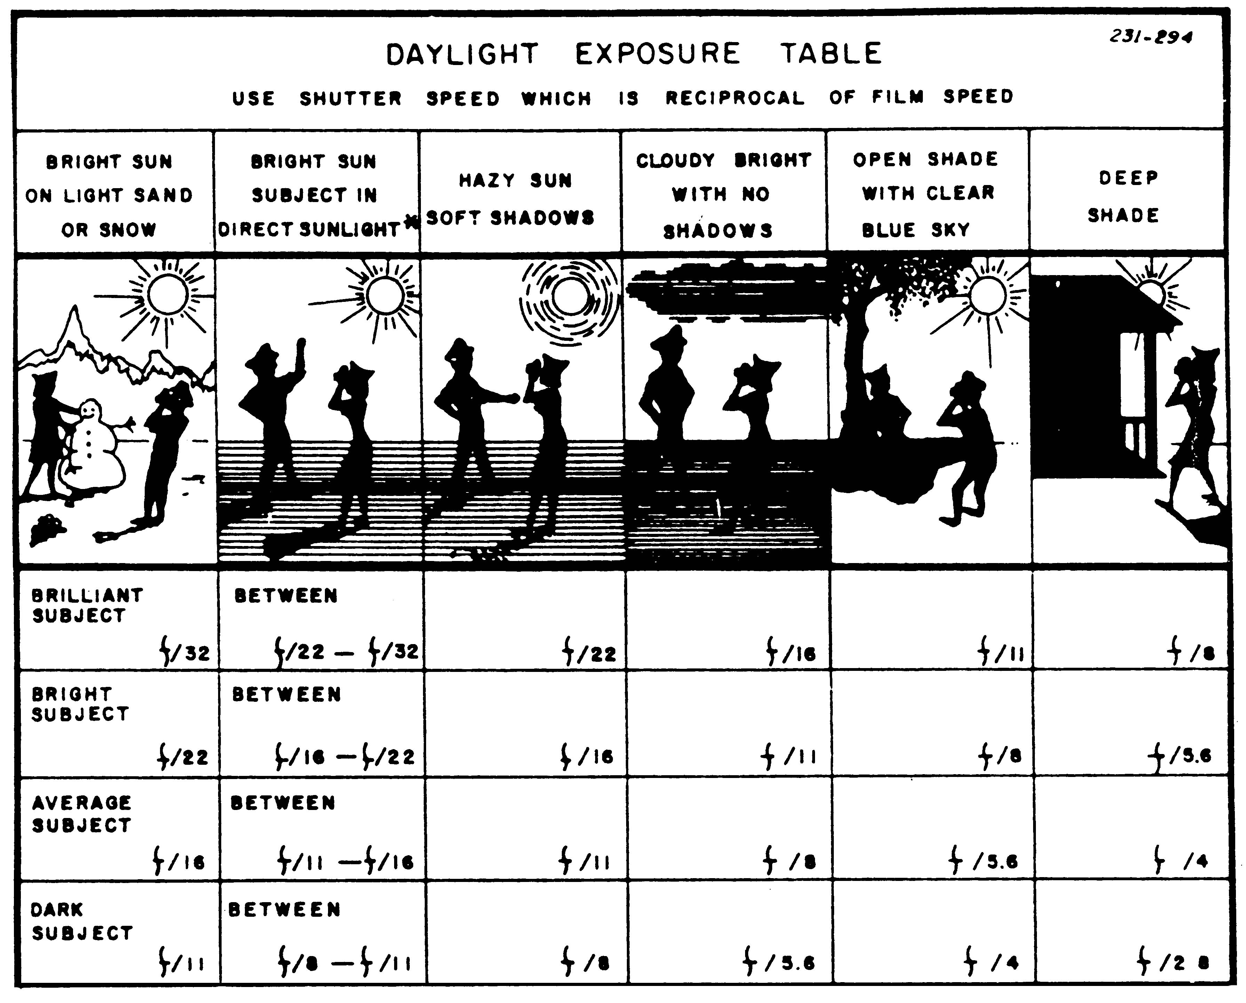
FIGURE 2-1. EXPOSURE TABLE

Underexposure, or too little light, results in a loss of tone separation, contrast and detail in the darker parts of an image. Underexposed images may produce an unusable dark blur.

Overexposure, or too much light, produces a light image with poor tone separation in the lighter parts of the picture. It occurs when the aperture is too large or when the shutter speed is too low.

Most films come with a daylight exposure table which you can use to get good exposures. In Figure 2-1 the table shows that when shooting a picture of an average subject (such as a fair-skinned person) in hazy sun you would set the aperture at f/11. Note that you should "use shutter speed which is reciprocal of film speed (with ASA/ISO 400 you would use 1/500th shutter speed, with ASA/ISO 125

you would use 1/125th shutter speed, etc.) Digital camera users should refer to their owner’s manual for ISO setting recommendations.

STORING AND HANDLING DIGITAL MEDIA

PCMCIA/PC Cards

All type III and some type II PCMCIA data storage cards have mechanical components similar to a computer’s hard drive and should be handled with similar care. If dropped, they may be damaged, resulting in the loss of all data on the card. They should be stored in a moisture- and dust-free environment. Most PC cards with mini-hard drives are designed for reliable operation in temperatures between zero and sixty degrees Celsius.

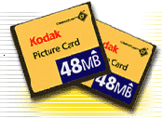

Compact/Flash Cards
All compact flashcards, all type I (and many type II PC cards) use solid-state (microchip) storage technology.

These cards are more robust than cards containing mechanical hard drives and can operate reliably in extreme (-55 to 125 Celsius) temperatures. However, data loss can occur if these are stored in an environment with a high concentration of electromagnetic radiation. Therefore, the digital data they contain should be uploaded into a computer for further processing or transmission rather than being stored on the cards for extended periods.


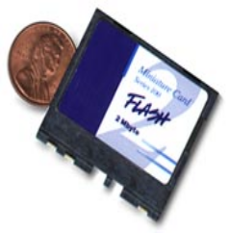

PRACTICE EXERCISE

LESSON 2

SUBCOURSE NO. PA 0250

RECORDING MEDIA

INSTRUCTIONS:

Review the material in this lesson. Answer the questions below by circling the "T" or "F" next to each question. Compare your answers with the answer key on the next page.

T F 1. Overexposure, or too much light, produces a very
light image with poor tone separation.

T F 2. Large "grain" size is normally a desirable
characteristic.

T F 3. Lighting, exposure and development can affect
contrast.

T F 4. Type III PC cards can operate reliably in extreme
(-55 to 125 Celsius) temperatures.

ANSWER KEY

LESSON 2

SUBCOURSE NO. PA 0250

RECORDING MEDIA

1. True (Page 27)

2. False (Page 24)

3. True (Page 25)

4. False (Page 27)

LESSON THREE

MEASURING AND CONTROLLING LIGHT

46Q Soldier's Manual Tasks:
224-176-1336
224-176-1316

OVERVIEW

TASK DESCRIPTION:

In this lesson you will learn how to control and use light.

LEARNING OBJECTIVES:

ACTIONS: Describe the procedure in using light meters,
electronic flash and available light.

CONDITIONS: You are given the material presented in this
lesson.

STANDARDS: You will know the methods and procedure for
using electronic flash and available light.

REFERENCES: The material contained in this lesson was
derived from the following publications:

Soldier's Manual and Trainer's Guide for
Journalists
DINFOS Photojournalism Student Handbook

MEASURING AND CONTROLLING LIGHT

INTRODUCTION

Light makes photography possible. It is reflected from the subject, then it enters the camera and exposes the film or falls onto the digital camera’s charg-coupled device (CCD).

Scientists tell us that light is travels in waves. In many respects the waves of light can be compared to sound waves. Sound waves vary in length, and they register as different pitches. Light waves register as different colors. This principle will enable you to use light more effectively when photographing.

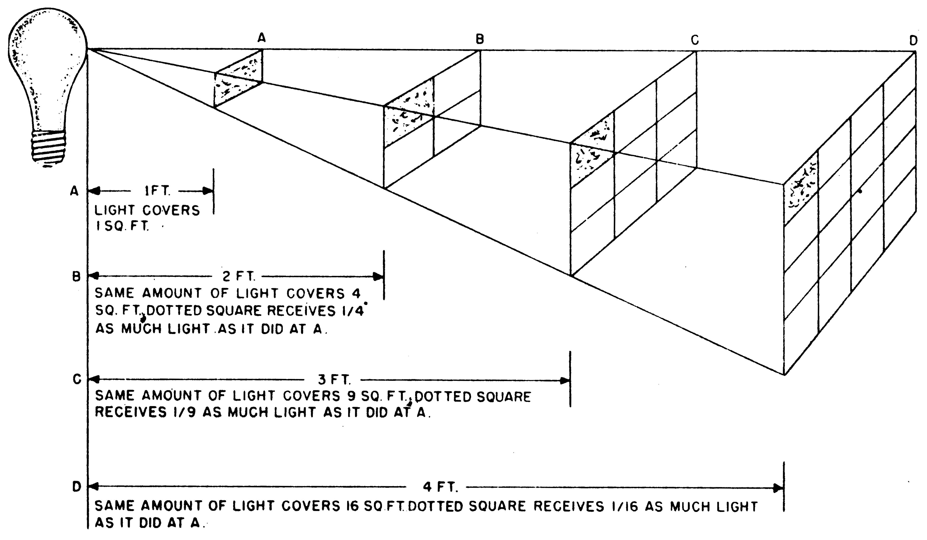
FIGURE 3-1. INVERSE-SQUARE LAW

In photography, light is the most important basic ingredient and must be measured accurately. The intensity of light determines the brightness of the subject. The formula that describes this is the inverse-square law (Figure 3-1). It states that light decreases as the square of the distance increases. Being familiar with
The light falling upon a subject from a source is called incident light. When incident light strikes a surface, it will change direction; this change is called reflection. If the surface is smooth the reflected light is said to be specular; however, if the surface is rough, the reflected light is diffused. Most objects reflect back both types of light.

Reflection is an important characteristic of light. It is how our eyes can see objects, how a film acquires a latent image and what the digital camera’s CDD electronically translates.

In this lesson you will learn about using light meters, shooting photographs using available light, electronic flash and filters.
Light Meters and Metering

Both the 35mm and digital photographer use photoelectric light meters to measure the intensity of light. These light meters have photosensitive cells that control the current as light strikes them. This current is measured by a microammeter, and the calibrations of the meter can be interpreted to give the photographer the required camera shutter speed and the lens aperture setting with a given film speed. Modern 35mm cameras and digital cameras use internal electronics to calculate exposure settings automatically. There are several types of light meters.

Reflected light meter
In this type of photoelectric light meter, the ammeter is calibrated to permit measurement of the amount of light reflected back into the meter by a particular subject. It should be aimed at the subject when used, because it will measure all of the light that it is aimed at (including backlight). This is the type of light meter built into most 35mm and digital cameras.

Through-the-lens meter
This type of reflected light meter reads the light being reflected from the subject into the camera’s lens. Almost all 35mm single-lens reflex cameras and digital cameras have a built-in, through-the-lens meter.

Some advantages of the built-in meter are that it is always available, compensating for filters (filter factor) is unnecessary and the meter reads only the picture area (if you change lenses the meter's angle of view changes too).

Used correctly, through-the-lens meters are accurate. But you will still need a handheld meter in situations that call for an incident light meter.

Be especially careful when shooting a subject that has backlighting. Don't hesitate to move in close to take the meter reading to eliminate the backlight from the camera's field of view, then move back for the shot.

Most through-the-lens meters are "center-weighted." That means they will give more attention to the level of light in the center of the viewfinder than the edges of the viewfinder. You should keep that fact in mind when using them.

Incident light meter
In this type of photoelectric light meter, the ammeter is similar to the one used in reflected light meters. In this meter, however, a diffusing device is placed over the meter light window to permit measurement of the amount of light falling on a particular subject. It should be held in the hand next to the subject and, when used, aimed at the light source.

Practical Light Metering
Photoelectric meters are valuable tools when used with common sense. Since every subject reflects various intensities of light with some shadow areas, one general reading does not give a correct measurement of existing light values.

Before measuring light values, determine the type of photograph needed. If shadow detail is important, measure the shadow area carefully. If the highlight area is to be emphasized, base exposure on the measurement of the highlight areas alone. To record both shadow and highlight areas in equal detail, measure both areas and use a compromise setting.

Do not make your light reading at a considerable distance from your subject, because this reading will include distracting areas that are not usually a part of the photograph. When taking specific readings, hold the meter close enough to the subject to indicate the average reflected light. The distance recommended is equal to the width of the subject.

If a strong backlight is likely to throw your meter reading off, then you should move in close enough so that the backlight is not visible to the meter. With a through-the-lens meter you can also do this by changing to a telephoto lens to get a reading on just the main subject.

Before using an exposure meter, make sure that the light value indicator points to zero while the photo cell unit is covered. If it does not, turn it in for repair.

Shield exposure meters from shock, strong magnetic influence, dampness, and extreme heat. Never point a reflection-type meter at the sun.

Check the calibration of a meter periodically against the quality of resulting photographs.

Substitution
The substitution method of determining exposure is simply the process of substituting an object from which to take a reflected-light reading when a reading cannot be taken in the usual manner. This method is useful when it is difficult to approach the subject close enough. It can be applied to small areas within a scene, either light or dark objects, or to an entire scene. In normal use, a meter should be held close enough to the principle object or scene to exclude all light except that which is reflected from the area to be included in the picture. Many times it is impractical to do this. In such instances, an object which has approximately the same brightness can be substituted. The back of the hand can be substituted when determining the light value of flesh tones, assuming the lighting where you are is similar to that of your subject.

Bracketing
If you have any doubts about the proper exposure for a particular scene then you should shoot additional exposures at one f/stop lower and one f/stop higher than the exposure indicated by the built-in meter. Many advanced 35mm and digital cameras have an “autobracket” feature which, when engaged, automatically brackets each shot. See your owner’s manual for details pertaining to your camera.

Advanced Exposure Metering Systems
Modern 35mm and professional digital systems incorporate several automated exposure metering options. These allow the photographer to choose a metering mode appropriate to the lighting conditions affecting not only the subject but also the objects within the frame’s periphery. Some (Kodak) examples—

Evaluative metering is recommended for general subjects and backlit scenes. By dividing the viewfinder into 16 metering zones linked with the five focusing points, the camera evaluates subject size, position (based on the focusing point in use), brightness, background, front lighting and back lighting to determine the best exposure setting.

Partial metering limits the metering area to the center of the viewfinder (approximately 23% of the image area). Select this mode when the subject is backlit or near a strong light source. Consult your owner’s manual for instructions on the use of your camera’s options.

AVAILABLE-LIGHT PHOTOGRAPHY

Available-light photography opens new doors to your creative talents. Mastering the technique takes only a few rolls of film and careful attention to detail. You will find that photography under available or existing light will be more realistic and preserve the mood just as you saw it. Also, you can enhance the technical aspect by selecting the camera angle, auxiliary lighting and type of camera support. From the technical side to the creative, it still remains the cameraman's responsibility to get the picture.

Types of Available Light

There are five different kinds of available light: fluorescent, window, window light with fill, single-point incandescent and single-point incandescent with fill.

Fluorescent light
Fluorescent light is normally found in offices, schools and public buildings. It is characterized by high overhead lighting that produces dark shadows under the eyes and other facial features. You will want to take a meter reading to include some shadow reading. Move in close and take your meter reading from a mid-tone skin area, such as a forearm or cheek.

Window lighting
Window lighting is normally one of the most pleasing and more beautiful types of lighting, when handled properly. It is a strong creative light, characterized by harsh shadows and brilliant highlights across the facial features when in direct window light. If you are lucky enough to have an overcast day, the effect is slightly different because the shadows soften much the same as in open shade. Since the sky is overcast, most of the light falling on the subject is diffused. Make your meter reading to include the shadow side of the face. This will ensure proper shadow exposure and detail. Be very careful about shooting into the window. Two things can happen:

o You may get a silhouette. Normally this will
not flatter your subject.

o You could come up with flare, which is also
unflattering.

You should try to make the most natural and pleasant photograph possible. These types of lighting will help.

Window light with fill
This is just one step better than normal window light. Your fill illuminator, whether a white card reflector or some nearby object reflecting light, will lighten the shadow areas and soften the harshness. This produces a most pleasing effect as well as improving your photographic technique. You will want to make a meter reading to include the shadow illuminator. A large white card works well for illuminating; however, remember that any book or newspaper held in close proximity to the face will work.

Single-point incandescent
This is a familiar type of light found in household lamps and overhead ceiling lamps, characterized by very directional shadows with little or no shadow detail. You will want to take your meter reading to include some shadow exposure. Since this light is very directional, it also is highly moody. If you find yourself shooting in a room where the light level is very low, you may wish to increase it by replacing the regular household bulb with a #2 photoflood (do this only when there is no danger of burning a lampshade). Note: Most household fuse boxes will only take two or three of these 500-watt bulbs before blowing a fuse.

Single-point incandescent with fill
When you use fill light with incandescent light, you have a choice of using a white card reflector or another incandescent lamp (electronic flash would give a different, unnatural quality of light). When using a bare bulb lamp, keep it at a distance so that it just adds some sparkle to the eyes and lightens the shadows. In some cases, you will use a bulb in a reflector. Do not aim the reflector directly at your subject. Secondary shadows and overpowering of your main light will result. Bounce the light off some nearby surface -- a wall, a ceiling, or white card.

Good lighting is important to obtain pleasing and lifelike results. Informal available light photography carries with it all the technical aspects of formal studio portraits. The application and desired result is sometimes slightly different.

SHOOTING A PHOTOGRAPH WITH AN ELECTRONIC FLASH

With its short duration, electronic flash (also known as a strobe) is an excellent source of artificial light for exposing both black-and-white and daylight color films and for digital imaging.

The burst of light is so brief it is easier on the eyes than bulb flash. All electronic flash units operate on the same principle: electric energy is built up within a capacitor (condenser) and suddenly discharged through a gas-filled glass tube, thereby creating the flash. Most units will recycle for another flash in a matter of seconds, as long as the batteries are fresh.

Using Electronic Flash

Set the ASA/ISO dial to match your film's rating. For DCS operation, set ISO, white balance and focus controls according to manufacturer’s recommendations.

Attach the electronic flash unit to the camera. This can be done by sliding the flash into a "hot shoe" or plugging a "PC" cord from the flash into the camera's "PC" plug. Since different cameras have different arrangements for hot shoes and PC plugs, you should refer to the camera's instructions.

Check the flash unit batteries. (Normally, camera manufacturer instructions list procedures for checking the batteries. In normal use, as the batteries lose strength, the recycle time between flashes greatly increases.)

Set the flash to the proper film speed/ISO setting. Set the flash in either automatic or manual mode. Since every manufacturer's flash unit is different, read the instructions for your particular flash.

Set the shutter speed in accordance with flash synchronization guidance in the operator's instructions (normally, 1/60th or 1/125th for a 35mm SLR). It is usually indicated by a different colored number or a "lightning bolt" indicator. Failing to set the correct camera shutter speed can result in loss of the picture. Generally speaking, leaf shutters will synchronize at higher shutter speeds than focal plane shutters. Check your owner’s manual.

Set the aperture control to the automatic mode or the setting established by the flash-to-subject distance in feet or meters, e.g., f/11 for 0-15 feet.

Turn on the flash. Employ direct, diffused, fill or bounce-flash techniques to achieve optimum effects.

Using one of these flash techniques, you advance your film one frame, focus on the subject and depress the shutter-release button.

Check the flash's pilot lamp to check the battery charge. (Some flash units also indicate whether the exposure and lighting was sufficient. If the unit you are using indicates such, check this device with each exposure.)

Keep a notepad/audio tag record of caption information for each frame or sequence. (NOTE: As a learning tool, note flash and exposure information with each frame, if possible.)

Be sure to turn the flash unit off when not in use to conserve batteries.

Synchronizing Camera with Electronic Flash

The camera shutter must be synchronized with the flash unit to ensure that the shutter is wide open at the instant the camera triggers the flash to fire; modern cameras automate this function. Otherwise, only a partial exposure would result.

On many 35mm cameras, a shutter speed of 1/60 second is set on the camera to synchronize the camera shutter with electronic flash. Some digital cameras and advanced 35mm cameras may require exposure compensation, special mode settings or control settings; refer to the owner’s manual for specific guidance.

When electronic flash is used, there is usually no need for a fast shutter speed. The exposure speed is governed by the extremely short duration of the intense light -- not the shutter. However, a phenomenon known as a "ghost image" can result under certain circumstances. If your subject is moving quickly while you take the picture and the available light is sufficient to make an exposure on the film, then you might get a flash shot which freezes the subject -- while at the same time getting an available light shot showing a much-dimmer subject in motion. This usually happens when the available light is also relatively bright and movement is occurring. DCS users should comply with owner’s manual procedures. The owner’s manual provided by the manufacturer is normally the most complete and reliable source of information and operating procedures for their product.

Setting the Aperture

When shooting a flash photograph using the manual flash mode, you cannot rely on the camera's meter to guide you in setting the proper aperture for the camera. While many flash units have a calculator dial, which tells you at a glance what aperture to use for a given flash-to-subject distance, yours may not. Therefore, you should know how to calculate an aperture setting, given a flash guide number.

The flash unit’s manufacturer provides a numerical rating, or guide number, for a specific ISO setting. This number indicates flash strength and aids in determining the aperture setting for that ISO. Once the guide number has been established, it will always be valid for a particular combination of camera, flash unit, and ISO. If the flash unit has variable power and/or flash head positions, guide number tables for both feet and meters, are usually provided. You must be certain to use the correct table for your type of distance measurement.

f/ISO | 25 | 50 | 64 | 100 | 200 | 400 | 800 | 1000 | 1600  This table extract (feet) is highlighted to indicate a guide number of 98 for an ISO of 100 at a flash head position of 35mm.
24mm | 41 | 58 | 65 | 82 | 116 | 164 | 232 | 259 | 328
35mm | 49 | 69 | 78 | 98 | 138 | 196 | 277 | 310 | 392

To find the lens aperture, divide the flash-to-subject distance into the guide number. Example: A flash-to-subject distance of 12 feet divided into an ISO 125 guide number of 96 (for a particular flash unit) would result in an f/8 aperture.

Guide numbers are used as guides only. They can be changed to fit individual conditions of use. If your color slides are too light, use a higher guide number. If your negatives are not dense enough (too light) use a lower guide number.

The "automatic flash" unit or auto-flash mode is easier to use. It uses built-in photoelectric eyes. When the burst of light from the flash unit reflects off of the subject and returns to this photoelectric eye, it shuts the flash unit off. In effect, it "knows" when the subject has been exposed properly. So once the proper aperture has been set (different for each type of flash unit) you need only focus and shoot. Read the instruction booklet for the flash unit you are using.

Automatic flash units do have disadvantages and can be fooled. The photoelectric eye really can't distinguish between the subject and any other object, which happens to be in the picture. This can be a problem if there are any objects in the foreground and the subject is farther away. Some subjects reflect light better than others. That too, could throw your exposure off. When you have the time, use manual flash settings. But automatic can be useful when things are happening quickly.

Flash Techniques

Using flash techniques properly compensates for low existing light intensity. Below are several techniques you can use.

Direct flash
When the unit is in this position, light is flashed directly to the subject. The flash head is aimed directly at the subject. Direct flash often results in harsh shadows, bleached-out whites and lost details. The subject's shadow normally cannot be eliminated using this technique. The shadow can actually detract from the subject, so be careful when using direct flash. Direct flash can make a person appear mean and cold. In addition, a phenomenon called "red eye" can result when your subject looks straight into your direct flash. The subject's eyes will look red or pink in a color photograph. This can be avoided by keeping the flash at least a foot or two to one side of the camera.

Diffused flash
With the flash in a direct flash mode, open up one f/stop setting. The flash is diffused by placing a specially made filter in front of the flash head. Diffusion also can be achieved by using one or two layers of lens-cleaning tissue or a white handkerchief over the flash face. As in direct flash, the subject's shadow normally cannot be eliminated. Again, the harsh shadow tends to detract from the subject.

Fill flash
This technique balances sunlight (or brilliant light) and shadows by illuminating the shadow areas, thus bringing out details. This technique is used frequently, for example, to illuminate the eyes of a subject wearing a baseball cap. Fill flash is used with another light source to eliminate or soften harsh shadows caused by intense directional light. The guide number of a flash could come in handy when using fill flash. A flash that is too strong or too weak might make fill flash difficult. Refer to the flash operator instructions for specific fill flash guidance, as directions vary from one maker to the next. With special energy saving technology, many manufacturers make units capable of limiting output power to one-half, one-quarter, one-eighth, and even one-sixteenth, with the flick of a dial. This is useful with fill flash.

Bounce flash
This technique uses the ceiling or walls to bounce light and cover a wide field of view. It works best with flashes that feature tilting flash heads. The head is rotatable from the direct-flash position (9 o'clock) to the straight-up (12 o'clock) position. Bounce flash often requires that the photographer open up two or more f/stops to make up for light absorbed by the ceiling or walls. You can determine the f/stop setting by determining the distance from the flash to the ceiling or wall, and then from that point to the subject. Add the two distances for your total distance. Then you must consider the color and texture of the surfaces used in bouncing; darker ceilings and walls may require another f/stop. Many flash units feature a sensor device which, in automatic mode, compensates for bounce flash by increasing the light output until the scene receives enough illumination. The sensor measures the amount of light reflecting off the subject and adjusts the time the flash is exposed to the subject accordingly. When using this method with a subject who has deep-set eyes, affix a plastic picnic-type spoon (concave side toward subject) to the back of the flash head with a rubber band. This will redirect some of the flash directly to the shadow areas. The end result will be more balanced lighting of the subject.

Split-beam flash
This method combines bounce and fill flash techniques. A specially made bounce card is attached to the head of the flash in its bounce flash setting. Light is directed off the card and also off the ceiling or wall and to the subject. This technique produces an evenly illuminated background and subject, as well as soft shadows. It is widely used by modern photojournalists.

Open flash
Open flash is used to evenly light large dark areas. At night, or anywhere there is little ambient light, you can open a camera shutter (with the camera on a tripod) and leave it open while you fire the flash several times to cover the entire area. The shutter is set to "B" and the f/stop according to the guide number (the flash is not attached to the camera body).

FILTERS

The principles behind using filters are the same for color film, black and white film and digital photography. However, with few exceptions, color filters are used only in black and white photography. Only ultraviolet and polarizing filters are normally used in color and digital photography.

Function

The most important fact to remember about a filter is that it is exactly what its name indicates: a screen. It sifts light rays. This means that a filter adds nothing to a picture. The function of every filter is negative; it subtracts a part of the light, holding back certain of the rays in the rainbow of colors.

As you are beginning to see, a color filter is simply a color screen. It is placed (usually) in front of the lens to withhold from the negative a part of the spectrum of the light reflected from the subject. The amount and color of the light withheld depends upon the characteristics of the filter.

Apart from their optical function, filters are an inexpensive means of protecting a very expensive lens from scratches.

UV Ultraviolet (haze) Reduction

Ultraviolet rays do not focus on the same plane as other rays and therefore blur the image. Haze is the blue of the sky resulting from light reflected off the moisture in the air. At short distances the amount of haze is too small to have any effect on a photograph. At long distances the haze may be too heavy to photograph hills or buildings clearly. You can filter out haze because it is blue and ultraviolet light. For filtering purposes we can consider ultraviolet light as blue light. The UV filter is often kept on the lens all the time to protect the lens from being scratched.

Polarizing

Besides traveling in a straight line, light vibrates from side to side, up and down, and in all directions perpendicular to its direction of travel. When the light vibrates in one direction, it is polarized (see Figure 3-2).
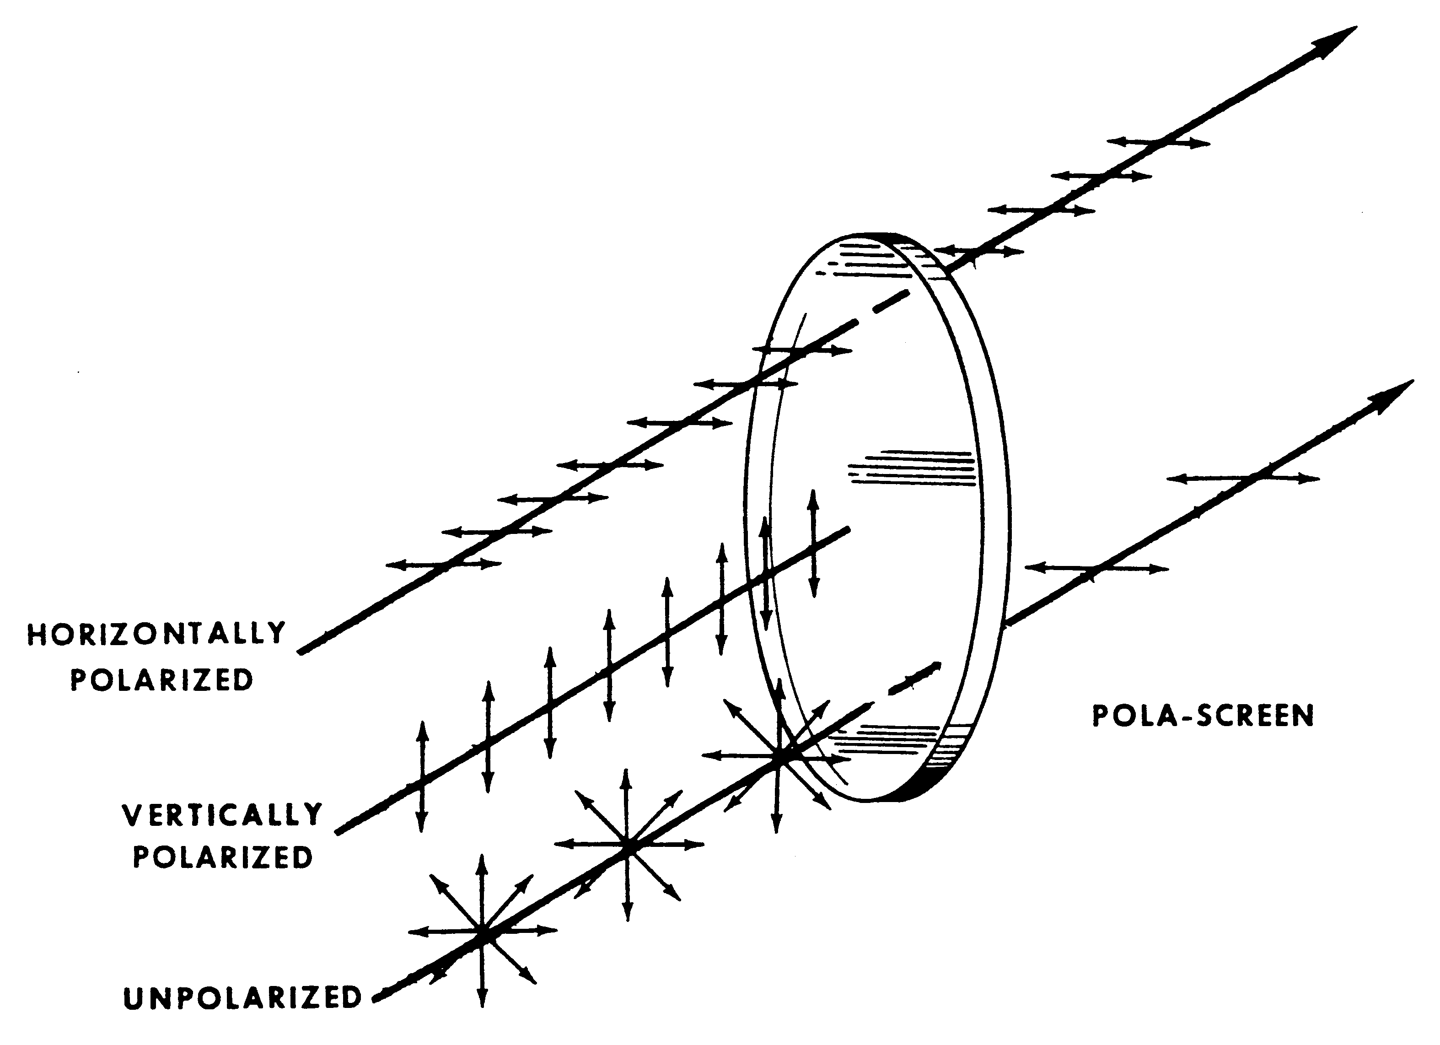

FIGURE 3-2. POLARIZING

Polarizers are transparent (pass light) to light polarized in one direction and opaque (filter out) when the direction of polarization is rotated 90 degrees.

A polarizing filter reacts the same with all colors of light as long as the polarization is the same. It is good for darkening blue skies without distorting color rendering of foreground objects. It is the only filter that can be so used in color photography. The greatest effect occurs when you're photographing almost at right angles to the sun. When photographing through glass or water at an angle, surface reflections interfere with the visibility of detail below the surface; the polarizing screen subdues the reflections and shows the detail. It can also be used the same way to bring out texture in such non-metallic objects as grained wood, linoleum, tile, lacquered or varnished objects, glass, leather, etc.

The most spectacular use of the polarizing filter is in color photography. It darkens the sky to an intense, vibrant blue -- if you are at a right angle to the sun. It brings out the green of the sea. It makes reds redder and yellows purer. It also eliminates reflections that dilute color. The polarizing screen is especially effective in photographing sunsets.

In general, the polarizer gives color images a saturation and richness that is unmatched. The polarizer has been called "the filter that drives color wild."

Effect of polarizer on the sky
As light from the blue sky is polarized, the polarizer will give an increased depth of tone at the optimum angle from the sun (90 degrees). This deepening of the sky becomes less as the angle from the sun increases or decreases. Therefore, the use of a wide-angle lens on subjects containing much sky area will produce a definite change of sky value across the image. It will be deepest at the optimum angle to the sun, and lighter on either side of this limited sky area.

The most consistent effect is obtained with lenses of long focal length. When the blue sky is polarized, clouds and haze are exaggerated in contrast against the sky. The sky itself is given more "shape" and total intensity.

Effect of polarizer on distant haze
The sky and atmospheric haze are subject to control by the polarizer. The greater the distance, the more obvious the effect. This can be adjusted and controlled by visual examination through the polarizer.

Effect of polarizer on water
Unless the surfaces of distant bodies of water are very smooth, the reflections of the sky will be broken and diffuse. The polarizing effect in this case will only be partial. If the surfaces are smooth and unruffled the polarizer will lower the values to a striking degree. Bands of color, cloud reflections, and the sheen of the sun itself can be modified.

Still water at closer distances may have sky and environmental reflections almost entirely removed. The filter can reveal details at the bottom of pools and streams that would otherwise be impossible to photograph. The degree of polarization can be visually adjusted to avoid losing the "substance" of the subject (pool, water, etc.).

Other effects
Glare can also be removed from glass and other glossy surfaces. It will not work on bare metal, however. Since each situation is different, the only way to know what a polarizer will do is to look through the viewfinder to see the result.

From this discussion we can thoroughly understand the wisdom behind this basic polarizing rule: Reduce or eliminate surface reflections only when it is of greater esthetic and practical importance to reveal what the reflections obscure.

Remember also, filters cannot eliminate solid particles in the air such as dust or smoke. Anything that blocks the light of the subject will prevent the camera from seeing the subject. Haze filters block the haze light, but they do not increase the light coming from the subject. There are many other filters available for special effects and unusual applications. Owner’s manuals and manufacturer’s catalogs explain their uses.
PRACTICE EXERCISE

LESSON 3

SUBCOURSE NO. PA 0250

MEASURING AND CONTROLLING LIGHT

INSTRUCTIONS:

Review the material in this lesson. Answer the questions below by selecting the "T" or "F" next to each question. Compare your answers with the answer key on page 50.

T F 1. Direct flash will usually give the most pleasing
portrait results.

T F 2. When you use the bounce flash technique, you must
open up your aperture to compensate for less
light reaching the subject.

T F 3. The UV filter may be kept on the lens to protect
the lens from being scratched.

T F 4. A polarizer filter cannot eliminate solid
particles in the air such as dust and smoke from
your picture.

T F 5. Still water at close distances may have sky
reflections almost entirely removed by polarizing
filters.

T F 6. A light meter that is built into a camera would
be an "incident light" meter.

ANSWER KEY

LESSON 3

SUBCOURSE NO. PA 0250

MEASURING AND CONTROLLING LIGHT

1. False (Page 37)

2. True (Page 38)

3. True (Page 39)

4. True (Page 41)

5. True (Page 41)

6. False (Page 32)
LESSON FOUR

ETHICS AND IMAGERY
46Q Soldier's Manual Task: 224-176-1335

OVERVIEW

TASK DESCRIPTION:

In this lesson you will learn ethical considerations involved
in photojournalism.

LEARNING OBJECTIVES:

ACTIONS: Describe the procedures used in processing
images for publication.

CONDITIONS: You are given the material presented in this
lesson.

STANDARDS: You will know the procedures, methods and ethical
considerations involved in processing images.

REFERENCES: The material contained in this lesson was
derived from the following publications:

Soldier's Manual and Trainer's Guide for
Journalists
DINFOS Photojournalism Student Handbook

ETHICS and IMAGERY

INTRODUCTION

Image manipulation for fun, publicity or profit is not new. “In-camera tricks” using superimposed images, special “props” or optical perspectives as well as “darkroom games,” fraudulent alteration of negatives and prints date from the nineteenth century. The bag of hoax photographs has included everything from the Cottingley Fairies series (circa 1917) which fooled Sir Arthur Conan Doyle to the intentional miscaptioning of news photos. With the advancement of computer technology, manipulation of photographs has become easier and quicker.

The Cottingley Fairies

In 1917, two girls from Cottingley,
England, produced photographs of
fairies in the garden (Figure 4-1). Although few can view these photos today and accept them as real, that was not the case in the early 1900’s.
Published in newspapers of the day, many accepted the photos as evidence for existence of fairies despite lighting anomalies and the fairies’ cartoonish appearance.

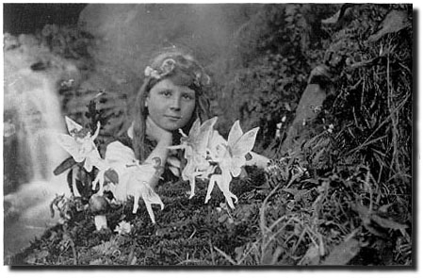

Hale-Bopp and “Friend” FIGURE 4-1
 | 
FIGURE 4-2 “Images of comet Hale-Bopp showing a mysterious companion are fraudulent. The companion object is not real, having been added to the image most likely using digital image processing techniques.” Adapted from Dr. David Tholen’s statement about the "Mystery Image. The fraudulent image was positively identified as based on one of Dr.Tholen's images and used without his knowledge or permission.

ETHICAL GUIDANCE FOR JOURNALISTS
Photojournalists in the civilian community, as well as the military services have established guidelines to lead them through the ethical decision-making process.
For the armed forces, DoD Directive 5040.5, August 29, 1995, subject: Alteration of Official DOD Imagery, provides official policy and guidance. One of the most important aspects of image handling, and crucial to implementation of the directive, is understanding the difference between enhancement and manipulation.

Enhancement vs. Manipulation

Enhancement
To make greater, (more attractive), “intensify,” i.e., density, contrast, etc. Repairing mechanical defects (dust, scratches, etc.) or optical defects (“red-eye,” etc.), caused by the photographic process is authorized and considered enhancement. Enhancement does not alter the content of the photograph.

Manipulation
To change by artful or unfair means to serve one’s own purpose. Electronic images are made up of pixels, which can be rearranged, changed, duplicated or eliminated. We can alter an image in almost any way imaginable: retouching, adding or deleting visual elements, creating montages and creating entire imaginary scenes.

Pixels, unlike traditional photographic materials, can be radically altered with no evidence (to most observers) of alteration. Once manipulated, photographs lose their “reality” and become no more informative than an advertisement or illustration.

Potential Areas of Abuse

Newspapers and magazines wishing to set ethical standards for their publications need to look at areas where abuse can occur and then decide the appropriate response for their circumstances.

o Contrast Control. A traditionally accepted darkroom technique, which is acceptable when done electronically unless, used to alter reality. (The O. J. Simpson photograph on the cover of Time magazine, which altered his skin tone.

o Dodge and Burn. Basic darkroom skills normally used to compensate for the under- or over-exposure of a portion of a photograph. These only become a problem when they change the meaning of the photo or misrepresent reality.

o Flopping. (To facilitate page layout) We have always been able to put a negative in the enlarger backwards but it was considered unethical to do this in the darkroom and it will continue to be unethical when done electronically. One indicator of flopping is the reversal of lettering on signs or name tags.

o Cut and Paste or Electronic Cloning. To move or add an element to change the nature of a picture is unethical. The cloning tool may be used to remove dust spots, scratches or other mechanical imperfections caused by the photographic process.

o Color Correction. Considered correct procedure in all color printing. It’s unethical to change one color, or on part of the picture by itself.

Read the extract of DoD directive 5040.5, below, keeping in mind what you have just learned about enhancement, manipulation and potential areas of abuse. Note that the spirit and intent of the directive is best summarized in paragraph D(3).

DoD Directive 5040.5, August 29, 1995 (Extract)

SUBJECT: Alteration of Official DOD Imagery

Reference: (a) Deputy Secretary of Defense Policy Memorandum, “Alteration of Official Photographic and Video Imagery,” December 9, 1994 (hereby cancelled)

A. PURPOSE

This Directive:

1. Supersedes reference (a).

2. Establishes policy and assigns responsibilities to ensure the absolute credibility of official DOD imagery in and outside the Department of Defense.

B. APPLICABILITY AND SCOPE (Omitted)

C. Definition

All photographic and video images, regardless of the medium in which they are acquired, stored, or displayed, that are recorded or produced by persons acting for or on behalf of DOD activities, functions, or missions.

D. Policy
It is DOD policy that:

1. Official DOD imagery is an essential tool of decision makers at every DOD level.

2. Mission success and the protection of lives and property depend on official DOD imagery being complete, timely, and above all, highly accurate.

3. Anything that weakens or casts doubt on the credibility of official DOD imagery in or outside the Department of Defense shall not be tolerated.

4. The alteration of official DOD imagery by persons acting for or on behalf of the Department of Defense is prohibited, except as follows:

a. Photographic techniques common to traditional darkrooms and digital imaging stations such as dodging, burning, color balancing, spotting and contrast adjustment that are used to achieve the accurate recording of an event or object are not considered alterations.

b. Photographic and video image enhancement, exploitation, and simulation techniques used in support of unique cartography; topography; engineering; geodesy; intelligence; criminal investigation; medical; research, development, test & evaluation; scientific; and training requirements are authorized if they do not misrepresent the subject of the original image.

c. The obvious masking of portions of a photographic image in support of specific security, criminal investigation, privacy, or legal requirements is authorized.

d. The use of cropping, editing, or enlargement to selectively isolate, link, or display a portion of a photographic or video image is not considered alteration. Cropping, editing, or image enlargement that has the effect of misrepresenting the facts or circumstances of the event or object as originally recorded is prohibited.

e. The digital conversion and compression of official DoD imagery is authorized.

f. Photographic and video post-production enhancement, including animation, digital simulation, graphics and special effects, used for dramatic or narrative effect in education, recruiting, safety and training illustrations, publications or productions is authorized under either of the conditions in subparagraph D.4.f.(1) or D.4.f.(2), below.

(1) The enhancement does not misrepresent the subject of the original image; or,

(2) It is clearly and readily apparent from the context or from the content of the image or accompanying text that the enhanced image is not intended to be an accurate representation of any actual event.

E. RESPONSIBILITIES (omitted)

F. EFFECTIVE DATE
This Directive is effective immediately.

PRACTICE EXERCISE

LESSON 4

SUBCOURSE NO. PA 0250

ETHICS AND IMAGERY

INSTRUCTIONS: Answer the questions below by selecting the "T" or "F"
next to each question. Compare your answers with the answer key.

T F 1. Dodging and burning a negative, or enhancing a digital
photograph to improve the contrast between the subject
and the background is contrary to DOD guidance.

T F 2. When processing a portrait shot for a news publication,
it is accepted practice to use digital enhancement or
darkroom techniques to remove “five o’clock shadow” or
blemishes from the subject’s face.

T F 3. You have taken a long-shot of a precision drill team
demonstrating the manual of arms. An officer, smoking
a cigarette is in the foreground to their right. Based
on DoD guidance, you may crop the officer out of the photo.

T F 4. You have a class graduation photograph, taken last June,
that shows the school commandant speaking from a podium.
The commandant just addressed a local Lions Club from the
same podium. According to DoD Directive 5040.5, you may
re-caption the June picture to run with the current story.

T F 5. The “friend” in the “Hale-Bopp and Friend” image, Figure
4-2, is an example of cloning technique.

T F 6. You can correctly assume that the image below, showing a
proud Army family, has been “flopped.”



ANSWER KEY

LESSON 4

SUBCOURSE NO. PA 0250

ETHICS AND IMAGE PROCESSING

1. False (Page 47)

2. False (Page 46)

3. True (Page 48)

4. False (Page 47)

5. True (Page 46)

6. True (Page 46)

LESSON FIVE

IMAGE PROCESSING

46Q Soldier's Manual Task: None

OVERVIEW

TASK DESCRIPTION:

In this lesson you will learn how images are processed.

LEARNING OBJECTIVES:

ACTIONS: Describe how film, digital and hard copy images are processed.

CONDITIONS: You are given the material presented in this
lesson.

STANDARDS: You will know the major steps involved in processing
film and digital images, and in scanning hard copy.

REFERENCES: The material contained in this lesson was
derived from the following publications:

Soldier's Manual and Trainer's Guide for
Journalists
Applied Journalism Handbook
DINFOS Photojournalism Student Handbook

IMAGE PROCESSING

INTRODUCTION

Due to transition to digital photography and environmental considerations, PA units no longer routinely process exposed film. Film processing must be commercially contracted or done by an appropriate signal unit/support activity. While darkroom-related Soldier’s Manual tasks have been eliminated for Public Affairs soldiers, some knowledge of black and white film development and printmaking are helpful precursors to a discussion of the digital imagery and scanning processes.

FILM DEVELOPMENT AND PRINT MAKING OVERVIEW

Development
The objective of the film development process is to make the latent image on the exposed film both visible and permanent by providing a permanent negative image of the photographed scene. Darkroom development involves removing the exposed film from its cartridge in total darkness and placing it in a developing tank where it is immersed in a succession of film development chemicals. Temperature of the developer, stop bath, fixer (hypo) solutions and the timing of each immersion must be carefully controlled. Upon removal from the fixer, lights may be turned on and the film washed under running water. Sometimes a clearing agent is used to ensure removal of all traces of the fixer. Additionally, in areas of hard water, a wetting agent might be used to ensure there are be no water-spots left on the film. Lastly, the film is placed in a dryer.

Printing
The initial objective of the printing process is to make a sheet of contact prints, each print the size of a 35mm negative. The dried film is cut into five strips of approximately six frames each. In the darkroom, the enlarger, a light projector, is adjusted to focus its light on the easel directly below. Working under a “safelight,” the contact sheet, an 8” x 10” sheet of light-sensitive photographic paper, is removed from its storage container and placed on the easel. The negative strips are then positioned on the contact paper and a sheet of glass is placed over them to ensure complete negative-to-paper contact. Then, a test print is made to determine the best overall exposure time for the film.

A piece of cardboard is used to mask all but the first strip of film. The enlarger is turned on for a period of three seconds. The cardboard is then moved to expose the second strip and both are exposed for another three seconds. The process is repeated until the last strip is exposed, resulting in a set of strips that have varied exposure times of from 15 to three seconds. Now, fully exposed, the sheet is ready to be developed.

The exposed paper is immersed in vats containing print development chemicals: developer, stop bath and fixer, before being washed under running water. After the test sheet has been developed, the optimum exposure time can be determined. Now, a final contact print is obtained by exposing all the negatives for the optimum time and processing the exposed sheet as before. Then, the final contact print or proof sheet, is reviewed to select the frames which will be projection-printed. These are the ones which present the most usable images and best support the story.
The projection printer (sometimes called an “enlarger”) optically regulates the size of the image on the photographic paper. During the time that the paper is being exposed, enhancement techniques such as dodging or burning may be employed to adjust the contrast of a portion the image. Once developed and dried, the projection prints are the final darkroom products.

Dodging and Burning

Dodging and burning are the processes of lightening or darkening parts of an image. In a conventional darkroom this is done during the printing process by positioning opaque masks between the enlarger and the paper. This is something of a hit-or-miss proposition as you cannot see the actual results until the print is processed. In editing a digital image, there are a number of different ways to perform these local tonal adjustments in a highly controlled fashion.

Cropping

Sometimes, the photographer or editor would decide to crop the picture to give better emphasis to the intended subject or to remove distractions. Cropping could be done by masking portions of the projected image or by cutting away the unwanted portion of the finished print with a pair of scissors.

A photo can tell several stories,
depending on how it is cropped.
Leaving this photo full-frame shows
the three runners who are leading
the pack of bunched-up runners farther back. Cropping recomposes the photograph. By eliminating some of the pack of runners on the right
side of the print, the editor can shift attention and feature the
intense competition among the
lead runners.

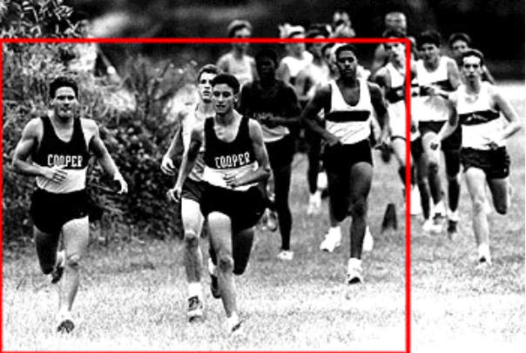

Post Production Responsibilities
The photographer must gather the negatives and final contact print and place them in an envelope, labeled and dated to reflect the story they support. This material will be archived for possible future use.

Photochemicals, except for wetting solution, are subject to an array of Federal, state and local laws addressing disposal of hazardous waste. You must learn and follow proper procedures for local storage or disposal of developer, stop bath, and fixer (with its recyclable silver content). These chemicals must be processed, not merely poured down the drain. The bottom line: photochemical disposal is both problematic and expensive, two good reasons for Army Public Affairs’ transition to digital photography.

DIGITAL IMAGE PROCESSING OVERVIEW

The Public Affairs Electronic Still Photography System (ESPS) consists of much more than the digital camera system (DCS), its accessories and peripherals. The ESPS includes major end-items such as, a data card reader; flatbed and film scanners; a high-end laptop computer with its own peripherals and software. The software includes programs that allow for importing or acquiring digital images and manipulating the images after they are acquired. In permanent settings, a high-end desktop computer may be substituted for the laptop.

Here’s what happens after completing a shooting assignment with a digital camera. Briefly, images stored in the DCS must be downloaded into a computer so they can be enhanced with image editing software for use in a publication or transmitted to a remote location. A scanner is used to digitize hard copy or film images so they too can be downloaded for transmission or enhancement. Lastly, the enhanced images are imported into a desktop publisher for placement in a publication.

DOWNLOADING DIGITAL CAMERA IMAGES

The goal is to download stored images into the imaging editing system (IES), a software program in the computer. Although the precise methods and procedures to download digital images into the IES may vary among specific digital camera systems and scanners, we will discuss the basic methods you will be expected to master: DCS to computer, PC card reader to computer and scanner to computer.

WARNING!! You must consult your owner’s manual for the specific procedures to use with your equipment configuration.

o Downloading from the camera, itself. The DCS’s firmware program allows it to “talk” to a computer that has been loaded with appropriate software or in which a compatible adapter-driver card has been installed. The camera is connected to the computer by a special cable provided for that purpose. An AC adapter is normally used to power the camera since the download function requires an uninterupted source of power.

o Downloading with a PC card reader. The PC card reader may be installed in the computer like a floppy disk drive (Figure 5-1)) or may be an external drive, connected to the computer by a special cable (Figure 5-2).

If you are using an external drive, the card reader must be turned on before the computer is turned on. Some systems require rebooting each time that you insert a PC Card into the reader. To use the card reader, insert the PC card containing stored images into the slot in the reader. When the PC card icon appears on the monitor’s desktop, the drive is ready. Follow the download procedures that are appropriate for your configuration and office SOP. After being downloaded onto your desktop or into a storage file you have created for them on your computer, the files may be imported into the IES for editing or enhancement.

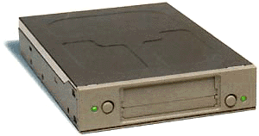
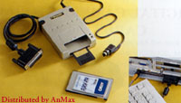
FIGURE 5-1
FIGURE 5-2

DOWNLOADING SCANNED IMAGES

Scanners, like digital cameras, use CCD technology and firmware to convert analog information to binary (digital) code files, which may be downloaded to a computer. A flatbed scanner, resembling a desktop copier (Figure 5-3), digitizes hard copy: photographs, text or artwork. Film scanners (Figure5-4) transmit high intensity light through the film, then through a series of lenses and electronic components to the CCD. Film scanners come in many sizes and can handle 35mm to 4”X5” negatives or larger. When using the scanner, you control input resolution and other settings using the scanning program software in your computer.

Once scanned and downloaded into the computer, the images can be imported into the IES for further processing or enhancement. As with digital cameras and card readers, refer to the owner’s manual for set-up and operating guidance.

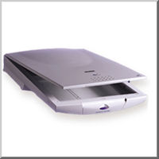
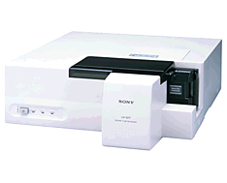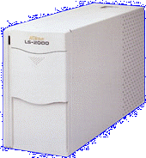
FIGURE 5-3 FIGURE 5-4

RESOLUTION

Resolution is a measure of the finest details that can be detected in an image. In digital imaging, resolution is measured in the number of pixels, in both height and width that make up an image. The higher the resolution of an image, the greater its clarity and definition. However, disk storage space, memory and data processing time requirements increase as resolution increases. Therefore, you must guard against “over-scan,” the use of unnecessarily high resolution. For example—If the image is only to be displayed on a monitor, then pixels per inch is the most important factor. The maximum resolution for most computer screens is 72 dpi. It makes no sense to scan at resolutions of 500 DPI if the image will only be shown on a computer screen.
For electronic image editing and processing, monitors used to view images may be set at a higher than normal resolution. Higher resolutions allow you to view a sharper looking image but they make the image appear smaller on the screen. Monitor resolution does not affect final image output, but higher than normal screen settings can make image editing easier.
Output resolution is the number of dots per inch, dpi, used to display a digital image on a monitor or in print. It is determined by the settings of the final output device (at DINFOS, 300 pixels/dpi per inch) and a mathematical formula.
You can use the following formula to estimate input scan resolution for halftone printing, the type of printing done by most military news publications:
Magnification x Output device resolution / 2 = input scan resolution setting
o Newspaper example. You want your image to be an 8x10 photo in a newspaper. The printed newspaper page (output device) has a 300 dpi resolution requirement.
10 (largest photo dimension) x 300 (output dpi) /2 = 1500 dpi input scanning resolution. (You will adjust the scanner input setting to 1500)
You must set your scanning device to capture the image at 1500 dpi to ensure optimal quality on the printed page.
o Online publication example. If your end product is an 8x10 digital image for a web page, and will not also be used in a newspaper, only a lower-resolution product, 72 ppi/dpi scanner output, will be required. The equation would look like this: 10 x 72 /2 = 360 ppi/dpi (input resolution setting is 360 ppi/dpi)

ENHANCING THE DIGITAL IMAGE

Electronic imaging completely changes the way the finished print is achieved—no more darkroom work—it’s all done at a computer terminal by the image editing system’s software. You will work with two types of controls: palette tools and menus. Palette tools are mouse-driven controls, which are used to alter portions of the image by hand. Menus control the more generalized functions, such as file saving, or commands, which are unable to be covered by using the mouse alone. Exploited by a skilled photojournalist, IES tools can produce products rivaling or surpassing wet photo technology.

Although based on Adobe Photoshop and Microsoft Photo Editor, the following explanations are provided only for illustrative purposes. Be certain to read and heed the documentation for the IES software you are using.

o Selecting an image. After acquiring images and while previewing them, select the photo you wish to enhance by clicking on the “Acquire” button. Then, using the “Save As” command, give it a file name and choose the format in which to save it (TIFF, Tagged Image File Format is commonly used). It is a good practice to save the image after completing each step in the enhancement process. Only a few of the many IES tools, functions and commands are discussed below.

o Cropping the image. The cropping tool allows you select part of an image and discard the remainder. Normally, you will crop immediately after acquiring and prior to sizing the image.

o Sizing the image. This menu function allows you to size the image to fit the space allotted for it in the publication by entering the desired dimension in a dialog box.

o Error correction. To allow you to correct an error, most IES allow you to use Undo, Revert and Escape commands to reverse a previous operation or to de-select the a completed operation which has not been “saved.”

o Adjusting the image. Unless your final product will be published in color, you will use a Grayscale adjustment to remove the color from your image. You will use the Brightness control to adjust the image’s lightness or darkness and the Contrast control to adjust the separation of tones.

o Eliminating imperfections within the image. The Rubber Stamp or cloning tool lets you take a “sample” of part of an image (some pixels) and place an exact copy (clone) elsewhere in the same or in another image.

o Altering the contrast of a portion of the image. Dodge and Burn tools or Smudge and Sharpen brushes are available to selectively lighten or darken portions of the image.

After the image editing process has been completed, the images are imported into a desktop publishing program. If necessary, the desktop publisher can re-crop or re-size the images before positioning them with the stories they support.
PRACTICE EXERCISE

LESSON 5

SUBCOURSE NO. PA 0250

IMAGE PROCESSING

INSTRUCTIONS:

Review the material in this lesson. Answer the questions below. by selecting the "T" or "F" next to each question. Compare your answers with the answer key.

T F 1. The objective of the film development process is
to make the latent image of the exposed film
both visible and permanent.

T F 2. A sheet of contact prints, developed and dried, are
the final darkroom products.

T F 3. Environmental considerations make photochemical
disposal problematic and expensive.

T F 4. The imaging editing system (IES), a firmware program in
the camera, permits extensive digital photo enhancement.
.
T F 5. Theoretically, 432 is the appropriate input scanning ppi
for a 9”x12” photo to be used only in an online publication.

T F 6. To emphasize the soldier, you would crop the image below,
discarding content from the right and bottom margins, and
then resize the image.

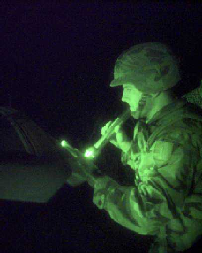

ANSWER KEY

LESSON 5

SUBCOURSE NO. PA 0250

IMAGE PROCESSING

1. True (Page 52)

2. False (Page 53)

3. True (Page 54)

4. False (Page 56)

5. True (Page 56)

6. False (Page 57)

Original Cropped and Resized


